6m Antarctic Beacon

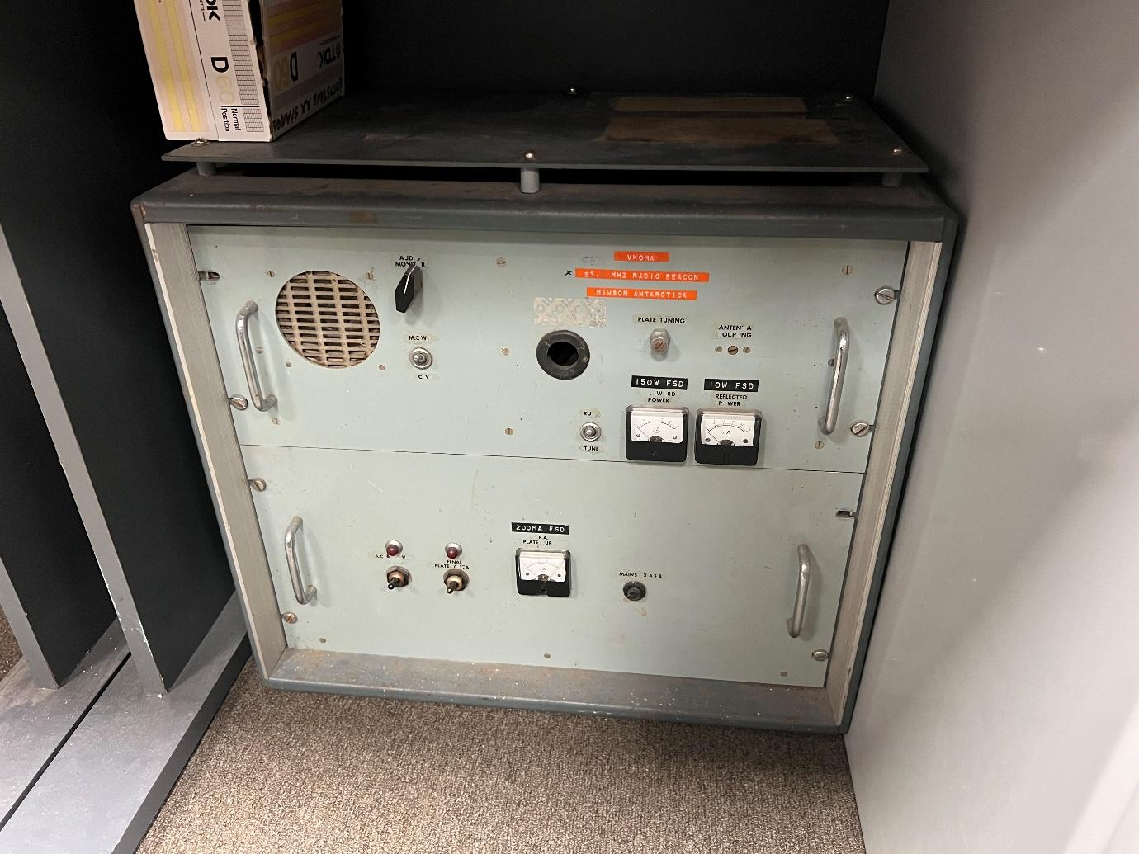
Keith Gooly VK5OQ - involvement with the beacon was limited to helping with the installation of one of them at Mawson in the summer of 1971, 72. They were designed by Gil Webster who was my manager for most of my 10 years with IPS. I don't know if Gil is still around. I met him at a few MWD's in Sydney. He wintered at Mawson one year about 1965, I think.
About the only detail of the beacons I recall is the output valve, tube is a 4-65A which probably points to an output power of 50 watts or so.
I recall the antenna, a 3 or 4 element yagi built like a brick "dunny" out of aluminium scaffold tube, very solid to resist the "Devil Winds of Mawson".
I have a photo or two of the antenna and maybe the beacon on its bench in the IPSO hut at Mawson I could probably dig out if interested. They're in B&W, developed and printed on the station.
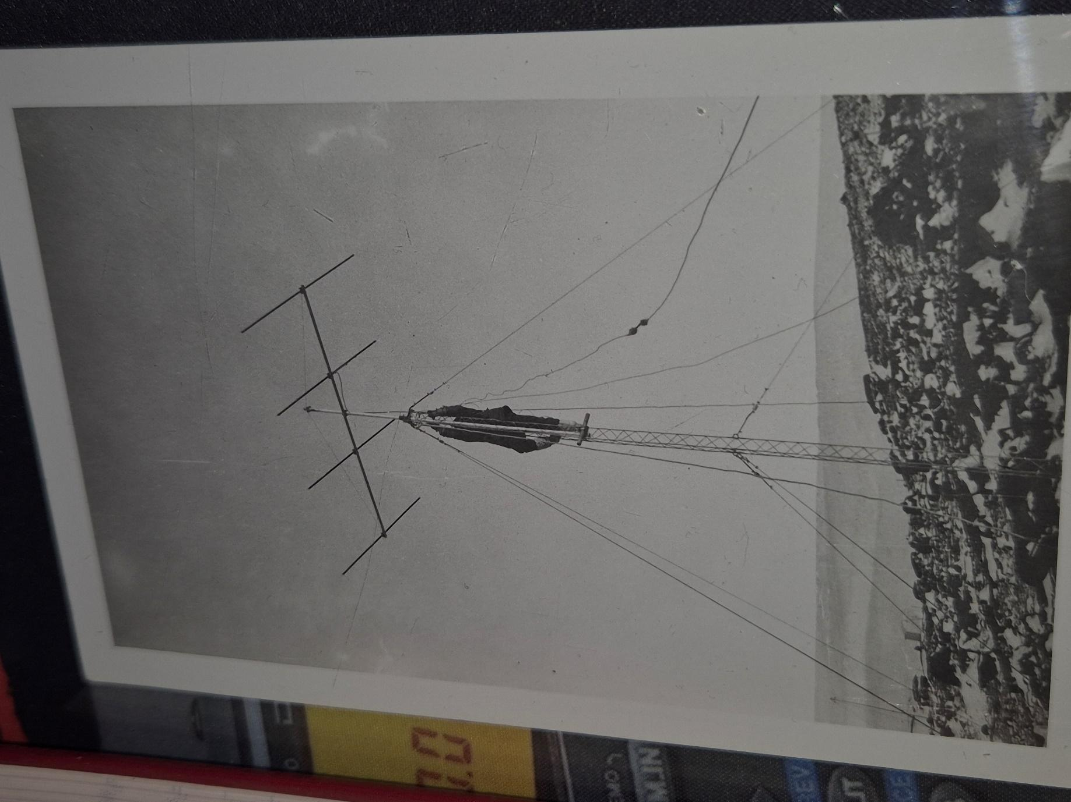
4 element yagi with me on the tower. January 1972
Keith Gooley VK5OQ

If there's anything I can add, let me know.

73 de
Keith Gooley
VK5OQ
vk5oq.sa@gmail.com

Item Donated by:
Kim Brigg VK7KB - bought at Gowans Auction - surplus AAD equipment
Alan Jeffery VK7KAJ / VK7KA involved and has some recollections

