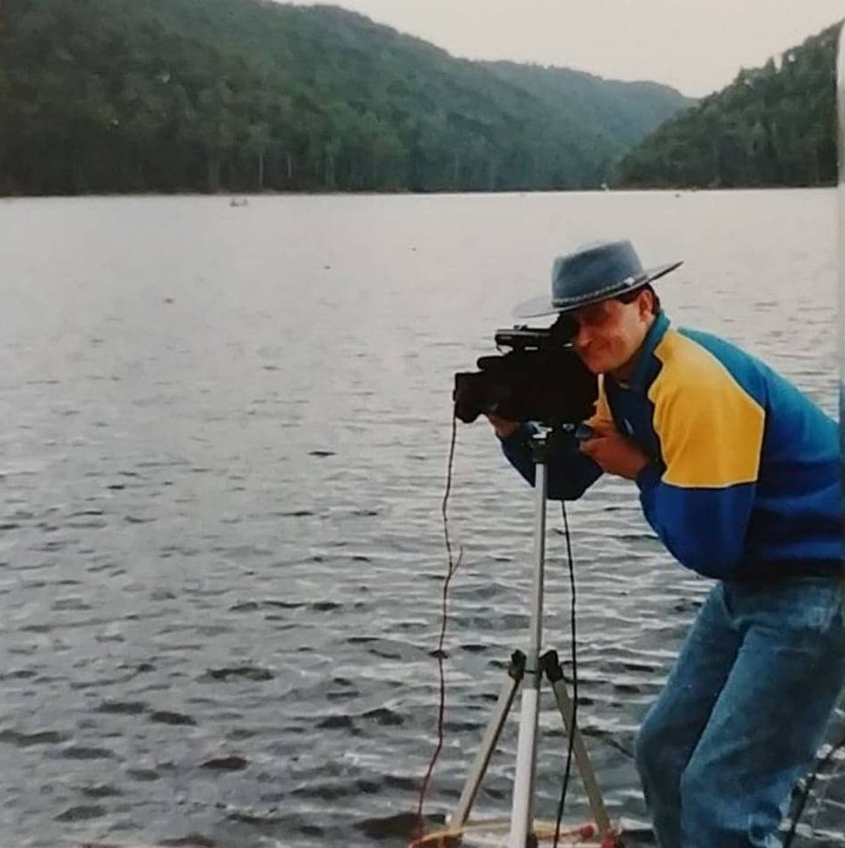
Andrew Perkins VK7KAP
World Rowing Championships 1990

