1
Hi Maddie, local amateurs and our National Body have supplied the following info and memories,
Hope you enjoy it
Regards
Eric
VK7EV

Clarrie Hilder VK7HC Silent key (an Amateur who passes away is called a silent key, relates to Morse Code key, it’s no longer working fell silent)
Any comments which state CW, relate to what is known as Morse Code
The reference to JOTA is Jamboree of the Air
JOTA-JOTI is an annual event in which Scouts all over the world connect with each other by means of internet and amateur radio. Short-wave radio signals carry their voices to virtually any corner of the world. t's the sheer excitement of having a live conversation with a fellow Scout at some other place in the world that attracts so many young people to this event.
JOTA-JOTI is a real Jamboree during which Scouting experiences are exchanged and ideas are shared.
The use of amateur radio techniques offers an extra educational dimension for Scouts. Many boys and girls grasp the opportunity to discover the world of wireless radio techniques and electronics.
Amateurs in Tassie, either invite Scouts etc to their houses or locations like the large scout facility behind Ulverstone, we set up shortwave radios, so local Scouts/Guides can talk to other Scouts/Guides around Australia and the world
26.2.1940 14th 10 2022
I knew Clarrie (Finishing Room foreman) and his brother Laurrie (Head Electrical engineer) from when i started work at Papermakers in Burnie back in 1976.
But as far as i know he was not an amateur at that point or when he finished work there, I don't recall seeing him since then.
He was certainly friendly and easy to get along with.
Cheers
Dave
Other amateurs commented Clarrie was a very private man, but selected people to tutor to get their amateur licence
Clarrie loved CW and spending time on HF Shortwave radio but did venture onto FM radios at times.
Apparently, Clarrie was in hospital once, and Trevor VK7TJ would visit on a regular basis, and they would communicate in Morse code clicking their tongues, the nurses and doctors were not sure what was actually going on.
A doctor came into Clarrie’s room one day, and found Clarrie and Trevor discussing a complicated circuit diagram from a project they were planning. When the Doctor realized what they were doing, he said to Clarrie, there’s nothing wrong with your brain, I’m stopping the medication, you can go, I think you are cleverer than me.
He was a member of the Tasmania division of the Wireless Institute of Australia
2

One memory I have is from the 1980s when Clarrie was a supervisor for amateur licence examinations.
My son, Dale, and daughter, Helen, sat for the full licence, as it was at that time.
Clarrie helped with the Morse code exam. It was held at our house.
My daughter passed and had her first amateur CW contact with Clarrie.
Clarrie was concerned that as she was Helen Cunningham (HC), she would want his callsign for herself.
She took her other initials and was VK7HJ for a time.
So I am pleased that the callsign has stayed in Clarrie's family.
Clarrie was also one of my only CW contacts as he was trying to reach some record for number of CW contacts.
Cheers,
Kirby
VK7KC
Clarrie VK7HC started his amateur life as VK7ZHC he was a long member of the WIA and a very dedicated WIA examiner in the 90's assisting many new hams get through their licence. Clarrie was a very keen CW operator with whom I had the pleasure of operating many Jotas with in the 90's.
Clarrie was very instrumental in getting me through my novice licence and spent quite a bit of time with me teaching me CW and the aspects of electronic theory. In June 1993 I passed my 10words a minute CW and passed my theory exam to get my novice call VK7MGS.Clarrie was thrilled to be my first CW contact on 80m.
Clarrie had a very nice station setup on HF with a complete Yaesu FT301s line-up and was very active on CW and was a member of the International DX Association.

There were two Elmer’s that were instrumental in me gaining my full call licence with 10wpm CW. They were Clarrie VK7HC and Trevor VK7TJ, whom are both sadly SK (Silent Key)

I owe a wealth of gratitude to these two gentlemen for their ever-enduring patience in getting me through the exam back in 1992 and their great support of me with the hobby.

By Graeme VK7KT
Our National Body, the Wireless Institute of Australia, supplied the below.
CALLSIGN(s): VK7HC
Information requested by: Eric VK7EV from NWTas. ARC – for a family member.
Name: Clarrie Hilder,
Previous known Address: 5 Speed St. Cooee Tas. 7320
The historian checked the yearly callsign call book and found entries in these years for Clarrie

Year Callbook Entry Details
Also checked 10 years previously. No VK7HC or VK7ZHC entry
1991 VK7ZHC Cooee
1992 VK7ZHC
3
1993 VK7HC, Cooee.
1994 As above
1995 As above
1999 As above
2000 As above
2001 As above
2002 As above
2003 As above
2004 Different address Unit1 5 Grey St., Upper Burnie, 7320
2005 Different address Unit1 5 Grey St., Upper Burnie, 7320
(Could this address be for the same property – perhaps a corner block – same post code?)
2006 No entry
2007 No entry
No entry for VK7HC could be found in Callbooks to 2019.
On the surface it would appear that Clarrie did not hold a licence after 2005.
However, it is known that some Government employees in special areas of activity, sometimes had their details suppressed for security reasons.

The HF or shortwave radio that Clarrie owned pic below a Yaseu FT301s

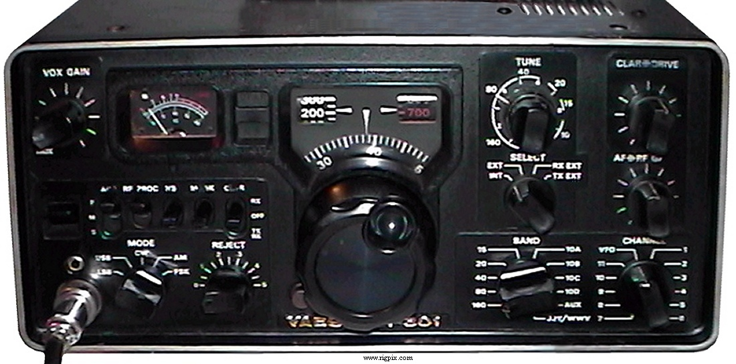

Below is a you tube link to a radio the same as Clarrie used listening to Morse Code, at the start of the video the di dah tones are Morse Code being sent by an amateur somewhere in the world

https://www.youtube.com/watch?v=MiB66thUTA4

4

Below are some QSL cards from Amateurs received from Clarrie to confirm radio contacts

Amateur radio operators exchange QSL cards to confirm two-way radio contact between stations. Each card contains details about one or more contacts, the station and its operator. At a minimum, this includes the call sign of both stations participating in the contact, the time and date when it occurred (usually specified in UTC), the radio frequency or band used, the mode of transmission used, and a signal report.
A typical QSL card is the same size and made from the same material as a typical postcard, and most are sent through the mail as such.
QSL card derived its name from the Q code "QSL". A Q code message can stand for a statement or a question (when the code is followed by a question mark). In this case, 'QSL?' (note the question mark) means "Do you confirm receipt of my transmission?" while 'QSL' (without a question mark) means "I confirm receipt of your transmission.

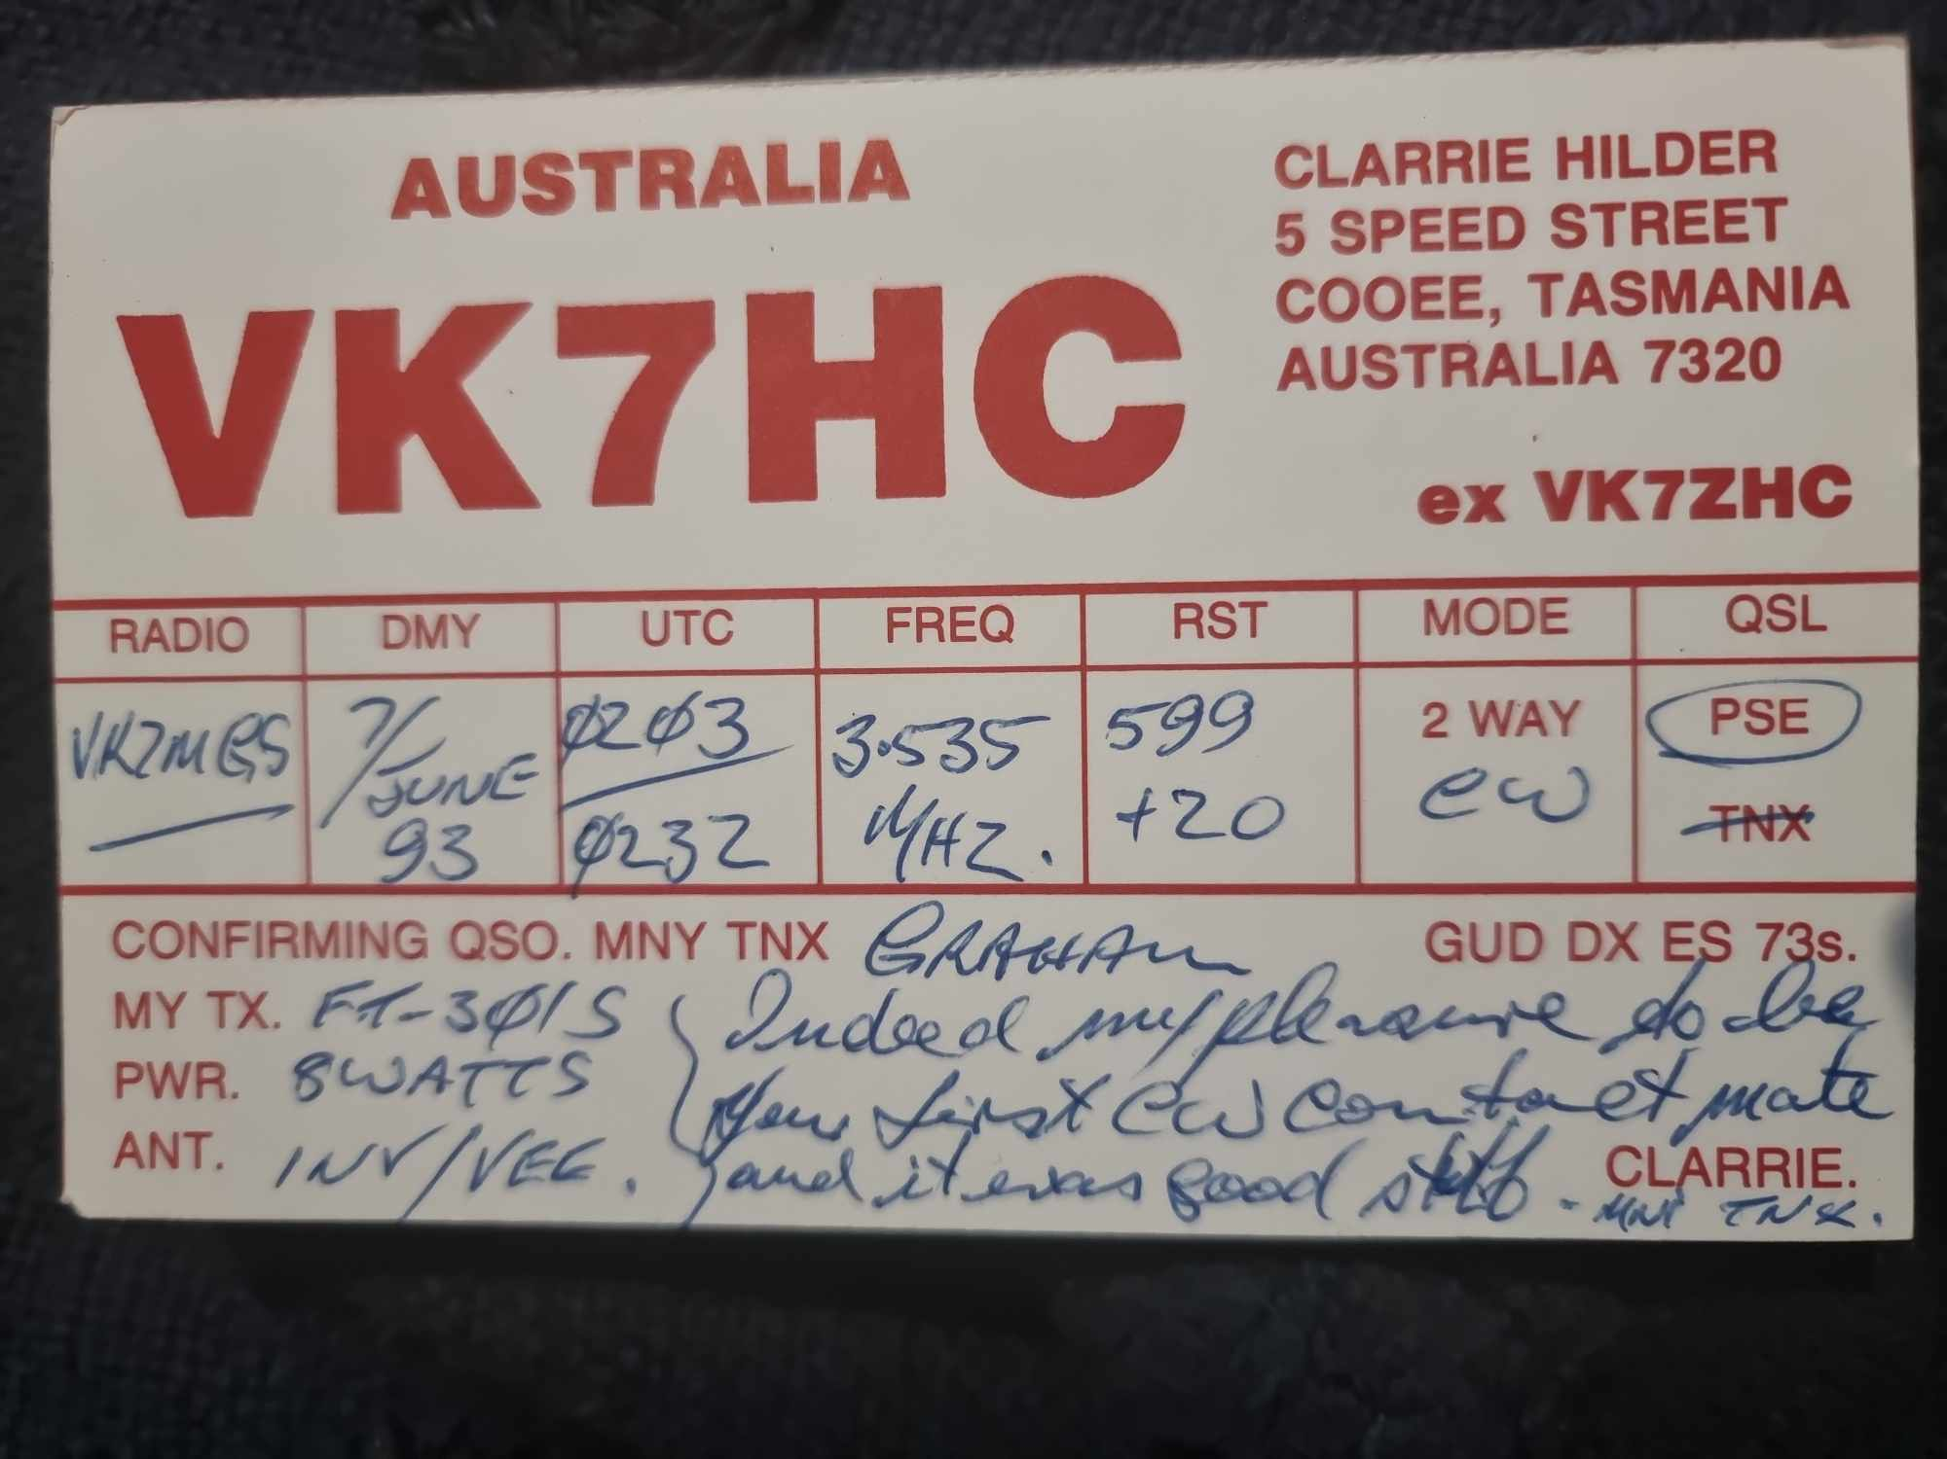

5

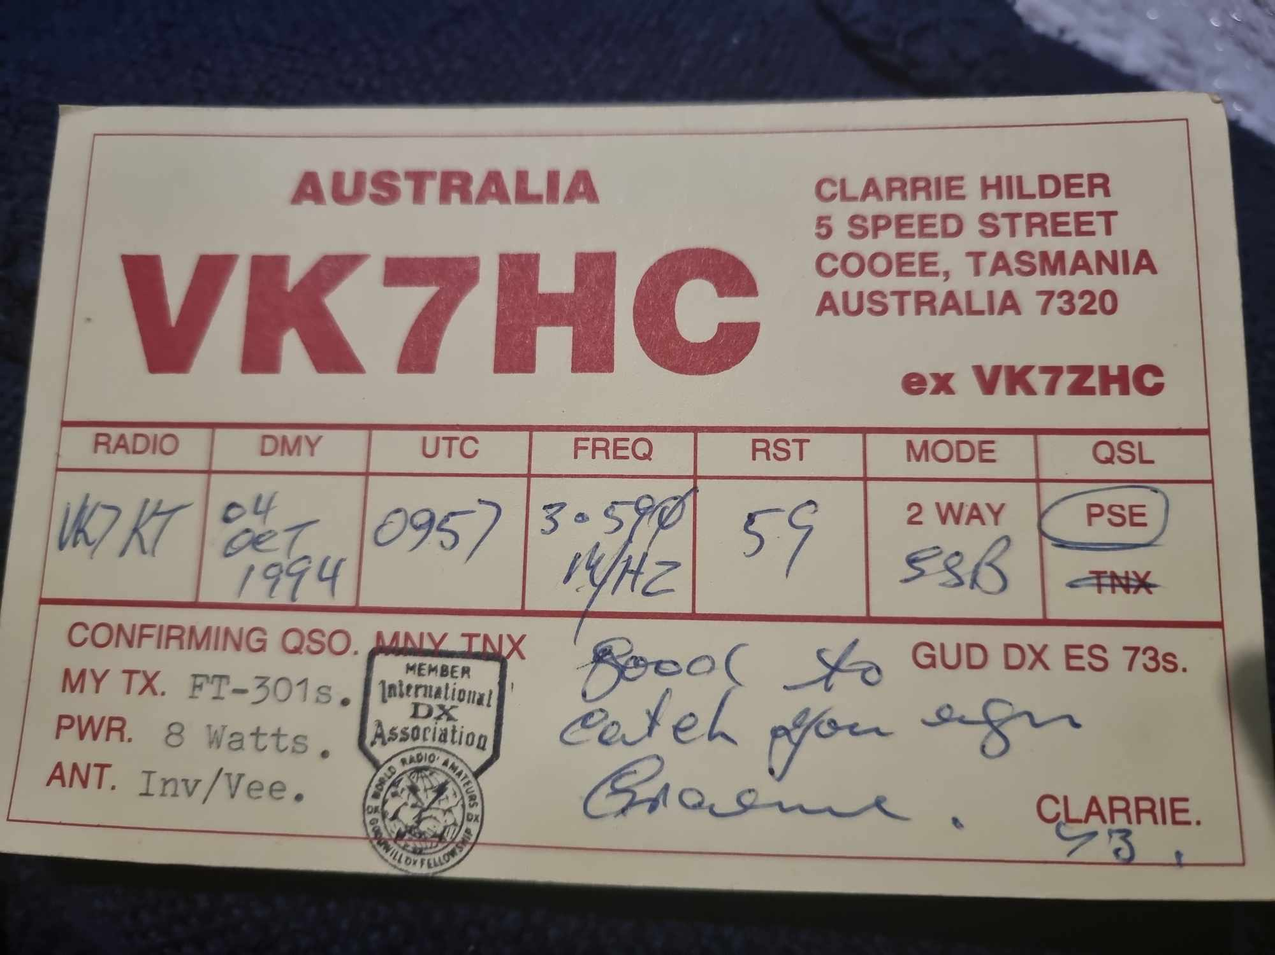

6

