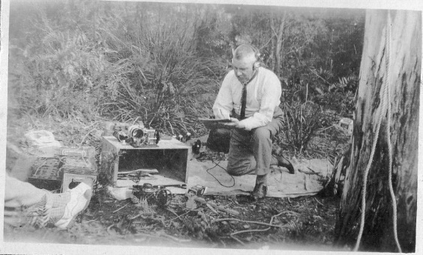
Transmitting station VK7AH
Grand Old Man of Radio - Pop Medhurst
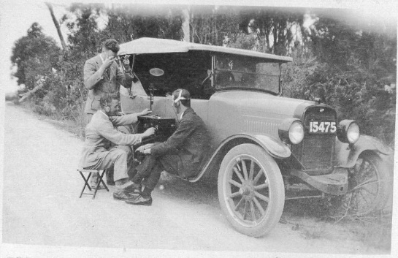

Receiving station

