F.W. (Pop) Medhurst VK7AH

Tasmanian Telegraphy, Telephony and Wireless Pioneer

By Justin Giles-Clark VK7TW

Introduction

As we celebrate our centenary in VK7 the author wanted to highlight one of the pioneers of amateur radio in Tasmania. The author worked with a Great GrandDaughter of Pop Medhurst and he thanks Alison for all her assistance with the development of this article.

Frederick William Medhurst affectionately known as “Pop”, came to Tasmania in the late 19th Century at the start of a technological explosion that saw the creation of our hobby of Amateur Radio. This is a great example of a person with ingenuity in the right place at the right time.

Frederick’s career development came through the official channels of the Post and Telegraph Department as a Telegraph Operator and Mechanist in both the United Kingdom and Australia and his involvement in the military and specifically the Royal Engineers. Throughout his employment and volunteer service he saw and embraced many business opportunities that presented as the new technology of telegraphy, telephony and wireless was being developed and installed throughout the world.

Interest in early radio saw him homebrew bleeding-edge spark transmitters and crystal sets and used them to further early amateur radio development and operation. Frederick was a supporter of the formation of the Wireless Institute Tasmania Division and held the post of President in 1929, 1930, 1934, 1937 and 1938. Frederick became Southern patron of the Tasmanian Division of the Wireless Institute in 1945 up until he became Silent Key in 1948 at the age of 81.

The following is a story of a true telegraphy, telephony and amateur radio pioneer!

History

Born Frederick William (Pop) Medhurst born in Chobham, Surrey, England in 1867. His father was a Chemist, he was educated at Nelson College, Lea, Kent, Surrey County School, Cranleigh then Electrical Engineering School at London Bridge.

Frederick started work as a telegraphist at the Chobham Post Office at age 14 and worked here for 8 years. During this time he undertook some military training at Aldershot in 1884 and spent time with the Telegraph Battalion, Royal Engineers and two years of Reserve Service with the 2nd Royal West Surrey Regiment - Volunteer Battalion - Signallers.

Whilst working in the Post Office he met Alexander Graham Bell - a Scot who moved to the US and was back in the UK promoting his new invention - the Telephone. There was a great affinity between Frederick and Alexander and they worked together to improve Bell’s invention. When Bell returned to the US he invited Frederick to join him, however Frederick’s heart was in Australia where Edith Emma Edney had migrated and Frederick joined the Edney family in 1889 and married Edith soon after.

Once in Tasmania Frederick spent two years with the Submarine Mining company of the Royal Engineers later transferring to the Mounted Infantry. After eight years he became Officer in Charge of Signallers in Tasmania a post he held until he reached retirement age just after World War One.

During this service Frederick was able to gain employment with the Post and Telegraph Department in Hobart in 1891 as a Telegraph Operator and Mechanic. On the home front there were five children born over nine years.

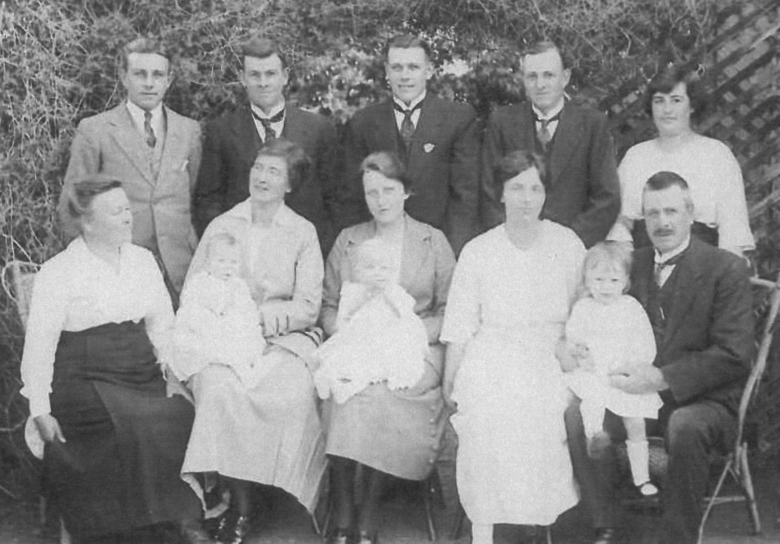
Photo1 - The Medhurst Clan circa 1920
Back row L2R: Medhurst children - Edney, Harry, Philip, Rowland, Edith Junior
Middle row L2R: Edith Senior, Kitty holding Wendall, Jessamine holding Helen, Dora, Frederick holding Doug

The Hobart Telephone exchange was being built at this time and Frederick saw an opportunity to contribute and build equipment here in Tasmania instead of importing expensive equipment from England. Frederick borrowed £600, a huge sum at the time, to buy equipment to manufacture components for the exchange. This was by all reports a success and created the foundation that Frederick built upon when he established the Medhurst Electrical Works and Telephone Coy. Ltd in 1912. Unfortunately the management of this company was left to people outside the Medhurst family and the family were effectively only employees, more on this later!

Frederick went on to supervise the installation of rural telephone services around Southern Tasmania and the East Coast. He either rode a horse or bicycle to most locations and was a keen cyclist who was known to compete on a penny farthing. It was during the very late 1800s and early 1900 that Frederick devised a system to send both telegraph and voice down the same phone lines using induction coils manufactured in the Medhurst workshop. The Post and Telegraph Department was so impressed that he was asked to implement the system in Southern Tasmania and was then sent to Queensland to implement the system.

With Marconi’s 1895 experiments with wireless technology, Frederick’s interest peaked and he set about learning all he could about the new technology. This led him to apply for the radio licence XFM and build spark transmitters and crystal receivers. In 1901 the Duke and Duchess of York (later to become King George V and Queen Mary) came to Australia on the Royal Yacht Ophir to open the first Commonwealth Parliament in the Exhibition Buildings in Melbourne. They were accompanied by two Royal navy vessels (St George and Juno) that were fitted with the new technology of wireless and on 2 July 1901 these vessels entered the Derwent River.

Seeing an opportunity to test his newly built equipment, Frederick employed the help of son’s Rowland 9, Harry 8 to lug the Fuller Block batteries (Medhursts were agents for these batteries), the spark coils (12 inch and 14 inch) and other gear down the hill to a site just above Blinking Billy Point where the equipment, a 90 foot mast made from scaffold poles lashed together and an end fed aerial were set up. Son Philip 6 rowed out with the earth wire and plate which he dropped into the Derwent river.

The receivers used were two coherer detectors of nickel and iron filings in glass tubes with two silver contact electrodes and decohered with an electric bell used as a tapper in one case and this was mounted on top of the sounder relay. This was duplicated as the coherers often became inactive due to oxidation and the filings had to be changed. The sounder relay operated a Siemens Morse Recorder. The Coherers were tested for activity using a spark gas lighter and a miniature Wimshurst machine that flashed a spark between contacts acting as a small transmitter.

As the ships came around the Iron Pot, Frederick tapped out a message of welcome. The signal was promptly acknowledged by the Royal Navy, a successful contact only five years after Marconi claimed to have bridged the Atlantic. W.P. Hallam the Post Office Chief Operator also contacted the St George and this is documented in the newspaper reports of the time.

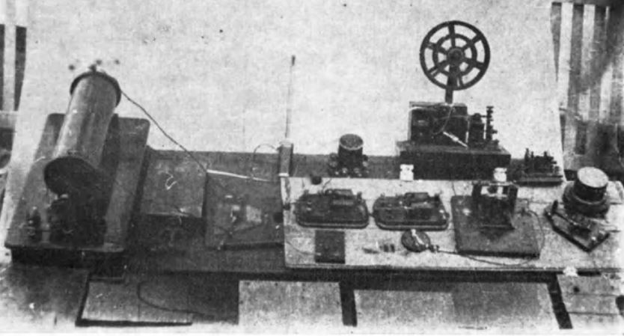

Photo 2 - Some of the original spark equipment used by Frederick Medhurst circa early 1900s.

This event was commemorated on 8th June 1985 with a re-enactment using a WWI Marconi Trench Spark Transmitter at Blinking Billy Point with special permission from the then Spectrum Management Agency to use ultra broadband spark! A video of the event is available. The WWI Marconi Trench Spark Transmitter used can be seen in the Devonport Maritime Museum.

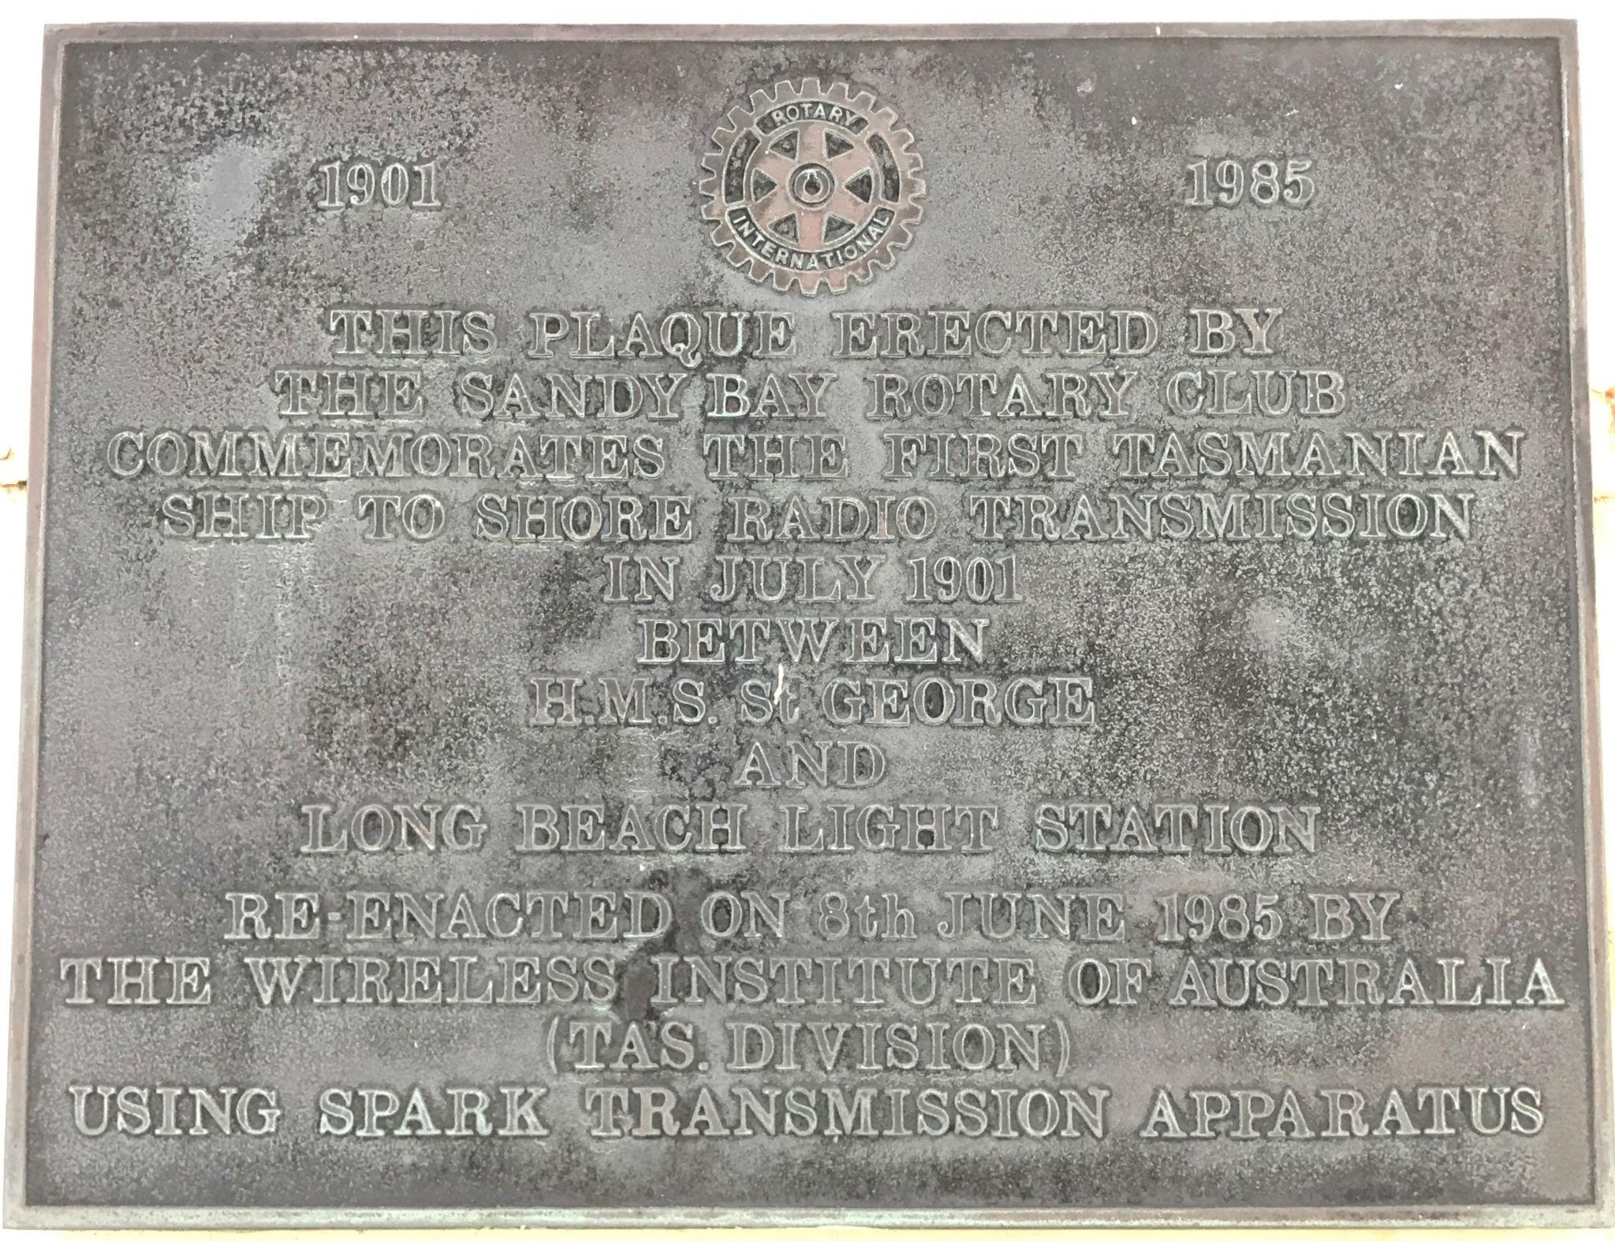

Photo 3 - Commemoration plaque at the Blinking Billy Point.

Frederick worked his way up to the position of Chief Mechanician in the Post and Telegraph Department and in 1906 retired to pursue other projects. One of these was the development of a lightweight (four pounds or 1.8 kilograms) portable Field Telephone which had a 150 mile (241 kilometres) range and he took out patents in six countries. Frederick and Edith sailed on the SS Mongolia to England in 1907 hoping to interest the War Office for Army use.

There was an amusing story whilst in London, Frederick took Edith to the Savoy Hotel to enjoy an elegant English meal however Edith after reading the menu said “I don’t fancy any of those dishes, may I have a plate of nice thin bread and butter please”.

Even though he could not convince the British Army to purchase the Field Telephone he did convince the International Telephone Company of London to manufacture the telephone and the metal plate picture below is one manufactured by ITC. This nameplate is riveted to a thick leather case that houses the field telephone and batteries. The demand in Europe was high and there were reports of more that 40 orders including India, South Africa, New Zealand and America.

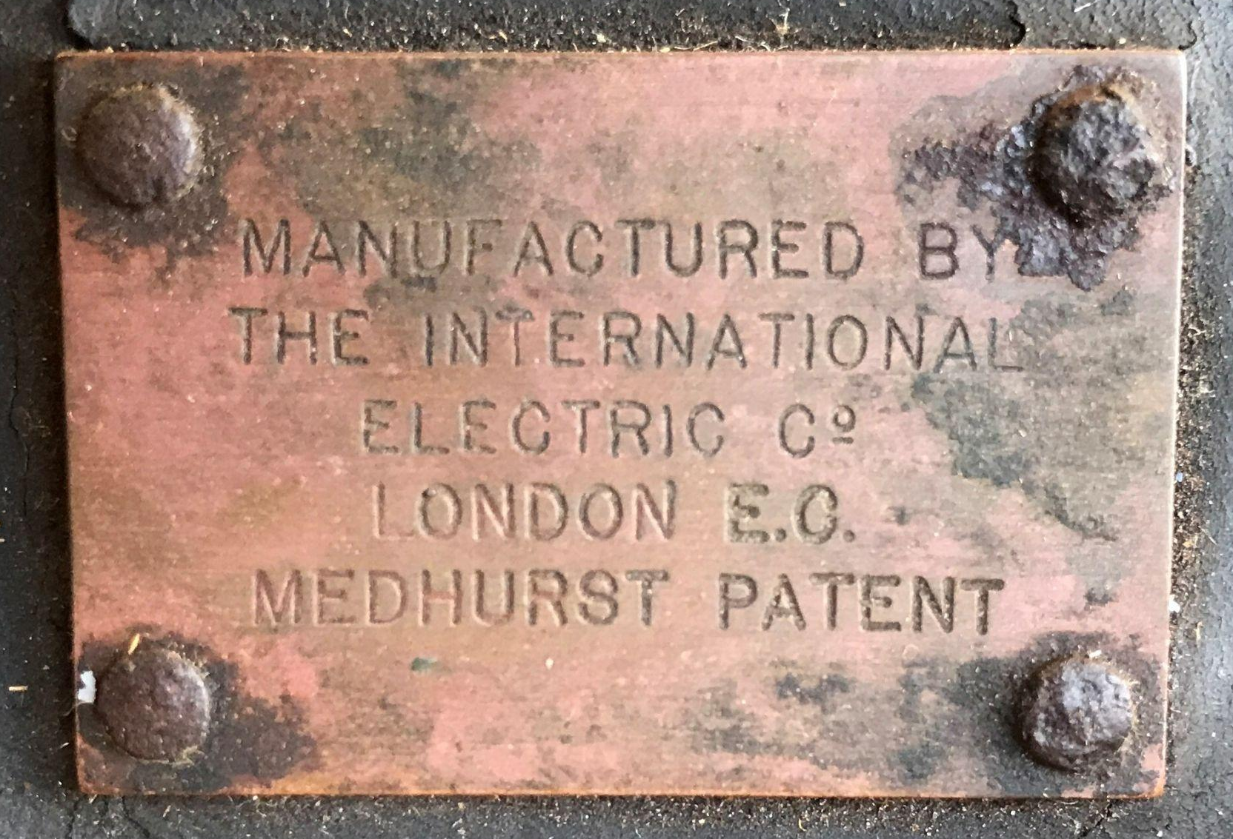

Photo 4 - Medhurst Field Telephone Case Plaque

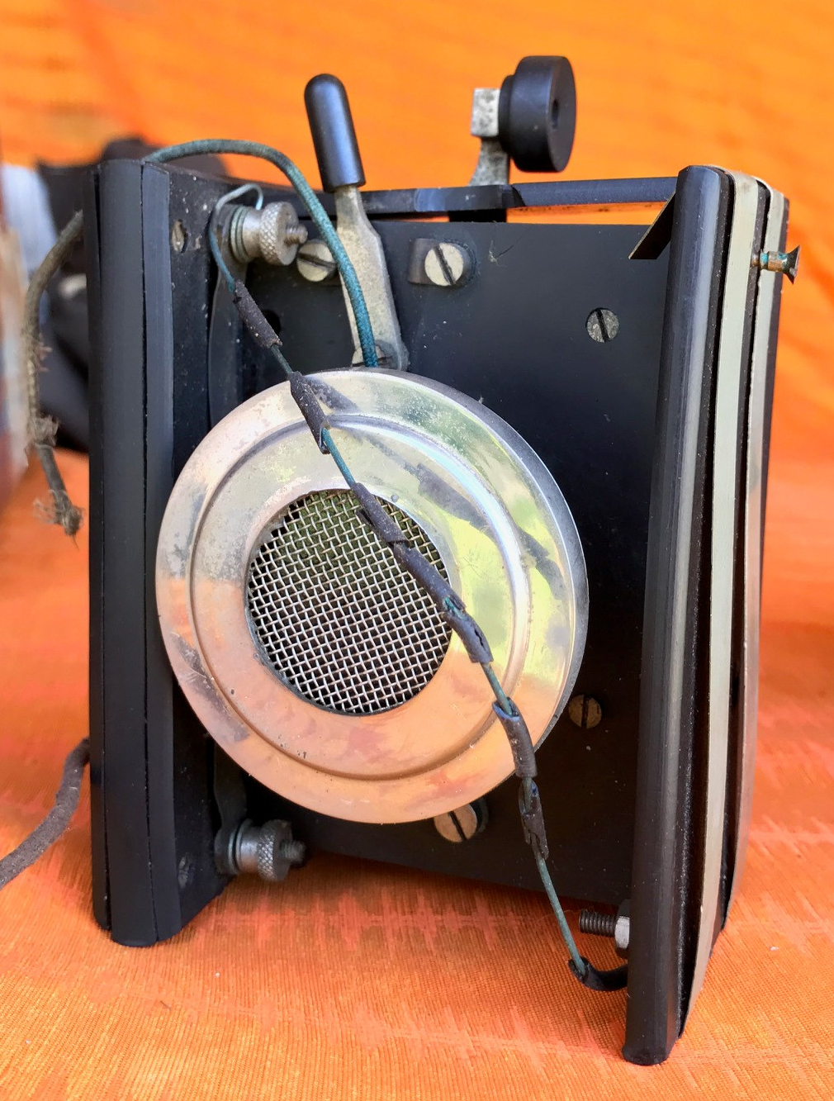

Photo 5 - Medhurst Field Telephone

Around 1912, Medhurst and Sons - Radio and Electrical installed the first electric lighting in Hobart. There were significant opportunities unfolding as Tasmania started to electrify using hydroelectricity generated power initially from the Waddamana and Duck Reach Power Stations. The Medhurst Company supplied and installed equipment at the Electrolytic Zinc Works at Lutana and the Carbide plant at Electrona. Profits steadily increased up to 1920 which was reported as £2411 and a first dividend of 10% paid to shareholders.

Unfortunately for reasons that are not immediately obvious the company fortunes took a dive and by November 1923 the company was put in liquidation. Company minutes show significant orders, stock levels and outlays coupled with Award changes that contributed to the demise and on 30th November 1922 Frederick was notified along with many family members over the preceding and following months that their services were no longer needed. Noting that there were no Medhurst Family members on the board. Efforts to trade out failed and the company went into voluntary liquidation in December 1923.

This would have been a difficult time for Frederick and the family however, being ever resilient and resourceful, the family regrouped and started Medhurst and Sons Pty Ltd selling domestic appliances like Falco irons, Hoover vacuum cleaners and Universal kettles at 95 Collins Street. In the attic Frederick had an experimentation space or shack - which contained many items relating to radio along with the “Influence Machine” otherwise known as a Wimshurst Machine and Leyden jars that could draw significant sparks.

Frederick was elected a life member of the Wireless Institute of Australia Tasmanian Division in 1925. He became Patron of the Wireless Institute of Australia - Tasmania Division in October 1945 after the post WWII reactivation of the Division. It is interesting that there was a Patron from the South - Frederick and patron from the North in Len Crooks VK7BQ. Maybe this was an early strategy used to manage North-South parochialism in Tasmania considering the rocky start to the Tasmanian Division in 1923.

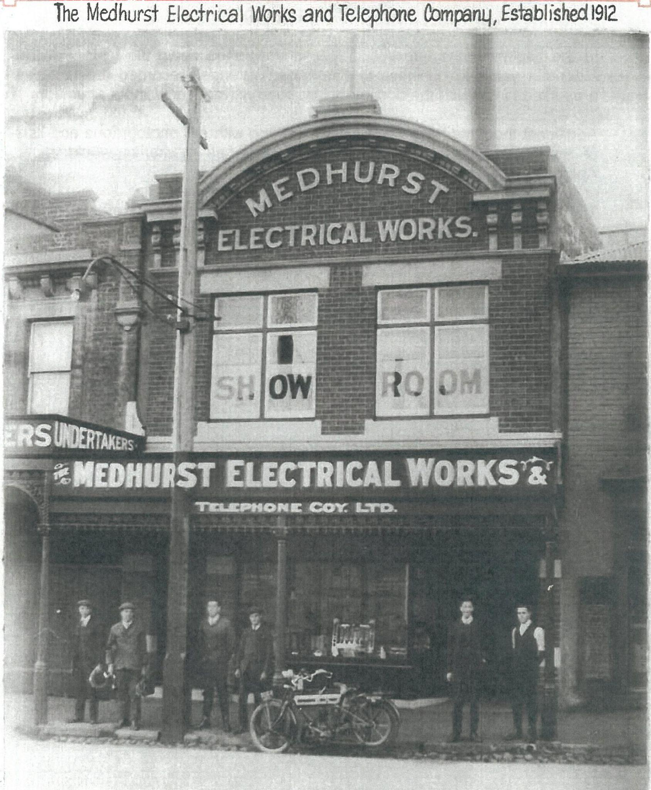

Photo 6 - Picture from the front page of the Medhurst Family Story
Medhurst Electrical Works and Telephone Coy in 1919 - 12-15 Argyle Street Hobart.

Frederick made an impression on most people he met and a good example is a 1926 letter from Sir Alan Cobham KBE AFC who was a pioneering aviator at the time and travelling the world promoting the new travel mode of aviation. Frederick broadcast Alan’s speech and received many comments that were fed back to Alan in a Telegram.

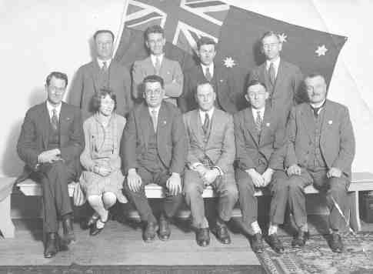
Photo 7 - 1928 Federal WIA Convention in Hobart
Back row L2R: VK3SW, VK5BY, Trevor Watkins VK7DX, VK3KB,
Front row L2R: - Len Crooks VK7BQ, stenographer, C. Scott VK7CS, VK3BM, VK3YX, Frederick Medhurst VK7AH

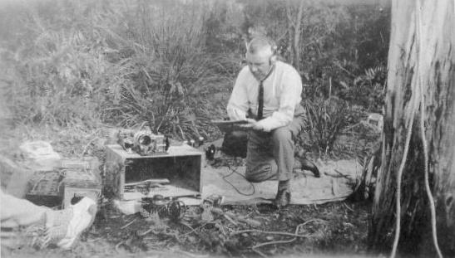
Photo 8 - Frederick operating at a 1929 Field Day - less the WIA Field Day Blazer!

The records from the late 1920s through to the late 1940s are patchy with attendances at Tasmanian Division meetings, photos at Field Days and exhibitions around the state.

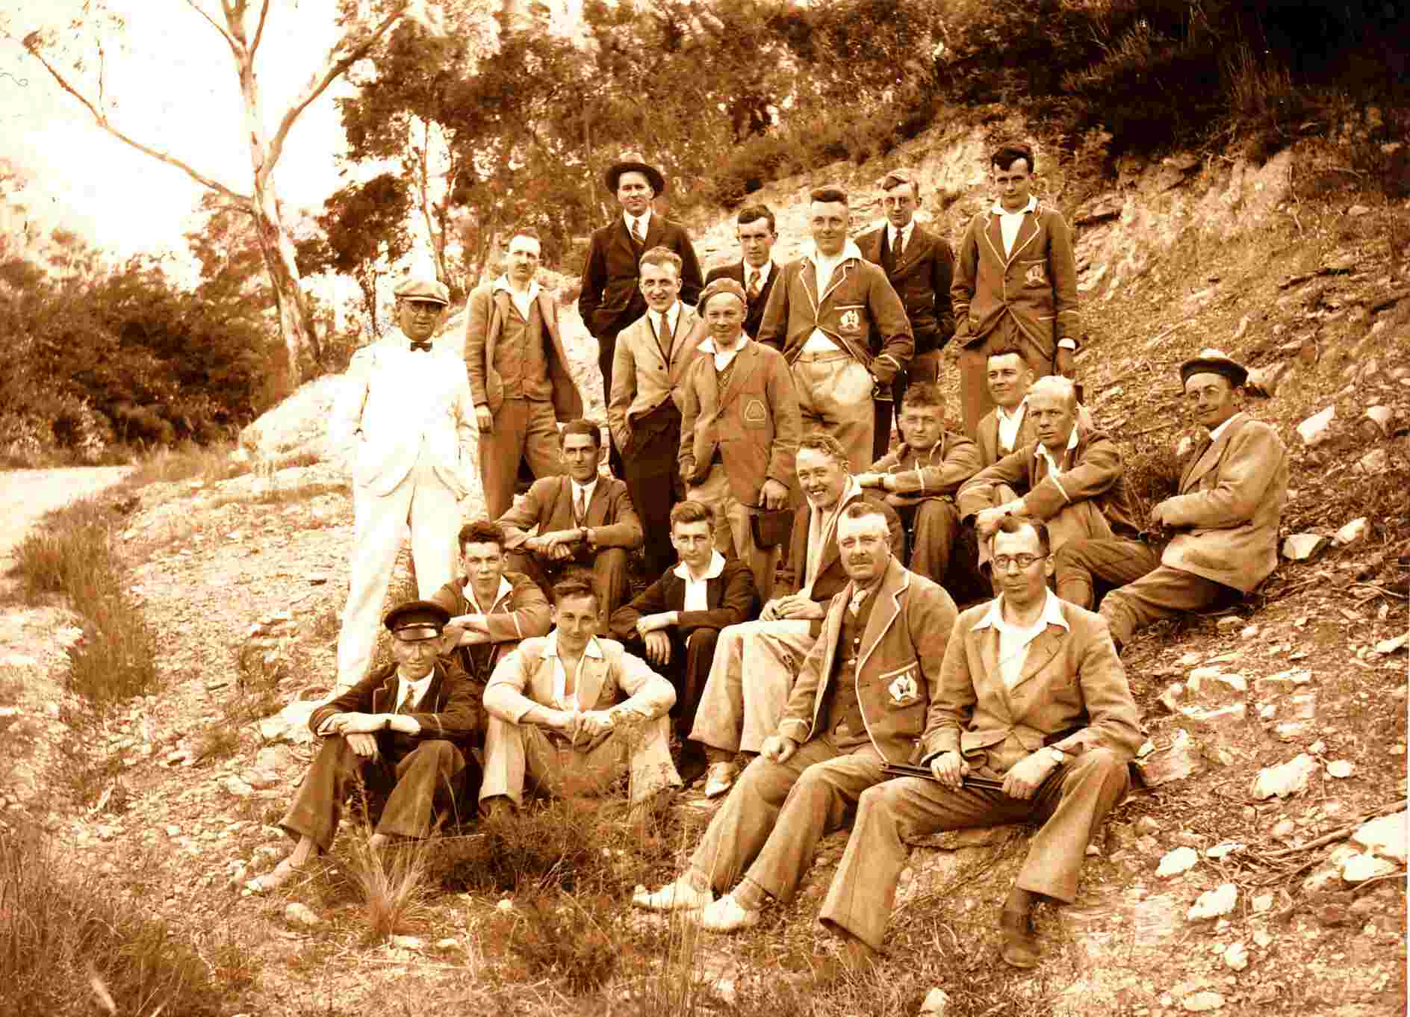
Photo 9 - WIA Tasmania Division Field Day 1932 - Frederick front centre - WIA Blazer

There are many references in the WIA Tasmanian Division Notes throughout the 1940s commenting on whether Frederick made it to Divisional meetings in Hobart. Frederick died on the 4th August 1948 after a short week-long illness and there was a two minute standing silence at the Divisional meeting held that night. In his Silent Key Notice it talks about Pop being a peacemaker in the Division - “he hated to see discord”.

At the time of his death - it was recorded that Frederick had a “Lyre shaped Edison talking machine” - Edison Cylinder players with electrically powered cylinder changers. He owned “breathtaking vintage radio gear” and a Penny Farthing Bicycle - the main wheel of which was used in his last invention that was a wind generator and 6volt battery lighting system at the holiday house he owned at Oyster Cove that was affectionately called “Fort Chimo”.

Conclusion

The thing that stood out to the author during the writing of this article was that Frederick was a man of his time - his ingenuity, experimentation, resilience and propensity for the practical held him in good stead during a time when the technology of telephony and wireless was exploding.

Frederick was able to harness, understand and use this technology to assist the government, the military and his own commercial interests and build profitable businesses.

We can only imagine what might have happened if Frederick had taken up the offer from telephonic royalty - Alexander Graham Bell to join him in the US. Tasmania may have been less for it but the telephone and telegraph technology development would have benefited.

His experimentation of early spark wireless technology with W.P. Hallam (Post Office Chief Operator) saw him make independent contact with Royal Navy Vessel in 1901 with equipment he built - alongside the “official account” with the newspaper reporting Hallam’s equipment as “makeshift”!

There are many reports found of amateurs visiting his house and shack at “Cranleigh” Beach Road, Sandy Bay and marvelling at the collection of innumerable relics of the past like a Western Electric valve receiver or a De Forest crystal set or an Edison talking machine.

Frederick is described as a “gifted and careful man, possessed of acute technical ability” and alongside the fact he was also described as a peacemaker who did not like discord. He is seen in many photographs in Launceston, Hobart and Field Days all over the state. He certainly appears to have been a calming influence over the early parochial rumblings between the North and South of Tasmania that plagued the established the WIA Tasmanian Division. This was recognised by the first WIA Tasmanian Division Life Membership awarded to him in 1925.

A huge thank you to Alison Medhurst and Rosemary Travers for information about the Medhurst family.
Thanks also to Linda Luther VK7QP for research and Phil Corby VK7ZAX for information on the Medhurst Field Telephone.

References:

2004, The Medhurst Story, W.W. Medhurst & W.D. Crosswell (TL.PQ 381.10994661 MED - Tasmanian State Library).

Personal Communications with Alison Medhurst and Rosemary Travers.

AHTS - Medhurst Field Telephone article - Linley Wilson - http://ahts.org.au/.

1985 Re-enactment of the 1901 Spark Contact with Navy Vessels - Sandy Bay Branch of Rotary International and the WIA Tasmanian Division - Dave Thorne VK7MR officiating.

Tasmanian Electrical and Radio Trader - March 1957 - Looking Back Over Fifty Years - Harry Medhurst Interview.

AR Magazine December 1938 - Reminiscences of VK7AH - https://worldradiohistory.com/AUSTRALIA/Amateur-Radio/Amateur-Radio-AU-1938.pdf.

AR Magazine December September 1948 - Silent Key VK7AH -
https://worldradiohistory.com/AUSTRALIA/Amateur-Radio/Amateur-Radio-AU-1948.pdf.

Various AR Magazine Archives - https://www.armag.vk6uu.id.au/.

Wikipedia - Alan Cobham - https://en.wikipedia.org/wiki/Alan_Cobham - Accessed 5/5/23

Tasmanian Royal Society Demonstration of Wireless
https://trove.nla.gov.au/newspaper/article/9426282.

WP Hallam contact with Royal Yachts
- https://trove.nla.gov.au/newspaper/article/157738285.
- https://trove.nla.gov.au/newspaper/article/9569556.

