WIA & Regional News Broadcasts in VK7
A brief history – (A Work in Progress)
Compiled by Justin Giles-Clark VK7TW
Last Update: May 2010
April 2023 Linda VK7QP

Roll Call:
1920s
Origin of the broadcast?
Radio in Australia and New Zealand Oct 15 1928 vol 2 no.6 supplement Ham notes
Fifth Wireless convention of the Wireless Institute of Australia
Held at Hobart on August 20 1928
Amongst the matters decided were: That the branches of the Wireless Institute in each State should operate a standard frequency station to transmit each week a wave which could be used by amateur for calibrating their frequency
1930s
July 1931 first bulletin
The Institute is holding a dance at 7ZL on Tuesday 11 August when we want to see a good roll up of members and their friends. The present suggestion is that proceeds of this dance be used to buy new gear for the Institute station VK7WI
There is no mention of any broadcast except from Richard 7RO notes:
1935 Jan 21 7WI given permission to broadcast at specific times on 1310 Khz (Music and announcements)

1940s
- Researching

1950s
Bob Fulton VK7AF and Terry Connor VK7CT were involved.
Terry was a pipe smoker and had the habit of tapping out his pipe as he spoke, so you always listened, expecting this to occur!
Then Tom Allan VK7AL took over and did it on and off for many years. The broadcast in those days often consisted of reading the contents of the Bulletin (not THE Bulleting), but the VK7 monthly news letter, which Tom used to pronounce as the Bullet INN.
In May 1964 a note in the newsletter states that 7WI rebroadcasts and slow morse, which have temporarily ceased, due to the absence of 7DK will resume again shortly
Tom Allen VK7AL did the broadcast in 1959 from the WIA meeting rooms in Liverpool St. Tom was a manager at the PMG.
Jack Batchler VK7JB was also involved.

1960s
Bill Maxwell VK7MX remembers in the early 60’s – trudging across the back suburbs of Burnie to Sid VK7SF’s to listen to the 40m AM broadcast and one day heard that the storm overnight had sunk some caissons that were being used to build the breakwater in Burnie – VK7KH could see from his shack window – it was the highlight of the week!
Through the 1960s Tom Allen VK7AL originated the WIA broadcast on 40m recollections are that it was noisy in Launceston. The broadcast in those days often consisted of reading the contents of the Bulletin (not THE Bulleting), but the VK7 monthly news letter, which Tom used to pronounce as the Bullet INN.
VK7ZJG John Grace rebroadcast WIA news on Sunday mornings for many years on 144.1 MHz AM then SSB, later on 144.15 MHz he's not in the 1961 Call Book, but is in 1963 (VK7RO)

In May 1964 a note in the newsletter states that 7WI rebroadcasts and slow morse, which have temporarily ceased, due to the absence of 7DK will resume again shortly
In 1967, Brian VK7RR was the editor of this august magazine and with it, came the responsibility of also collating and reading the news. As I recall, this was shared, much as it is today, between Tom, Terry and myself.
Peter VK7PD remembers hearing it on 2m AM which was picked up by 7DK from 40m AM where it originated. Launceston at that stage had cross band repeaters on 2m & 6m.

1970
The 70’s saw the formation of the Southern, Northern and North West Branches of the WIA Tasmanian Division.
Broadcasts alternated between Hobart, Launceston and Burnie each week.
Peter VK7PD recollects that during the time the broadcast originated in Launceston – Peter VK7PF increased the frequency of the repeater ident tone outside the bandpass of an SSB receiver so it didn’t get passed through to the SSB rebroadcasting.
Brian VK7ZBY was involved along with Reg VK7KK in Launceston.

Tom Allen VK7AL and Ted Beard VK7EB, Brian VK7VK, Snowy Harrisson VK7CH and Tommy Moore VK7FM were involved in Hobart. There was use of ABC facilities to create and edit the broadcast.
Tom had worked as a technical trainer with the ABC for years, and Brian was also technically trained, working with the ABC and later with the TCAE and various colleges in Hobart.
Joe VK7JG was involved with the 1972 for 12 months and recollects that repeater 2 (Mt Wellington - Hobart) and repeater 8 (Mt Barrow – Launceston) were linked by two radio back to back at Arthurs Lake in the Central Highlands (Frank Moore’s place) he used a chainsaw in tree to make hole with extension cord and generator – for two years! The VK7RIN link on Barren Tier in the Central Highlands took over and is still going strong.
At the general meeting following the VK7 AGM on 5 April 1975, Brian VK7ZBY enquired of those present if they were happy with the systems in place for the broadcast. There was reassurance that all was satisfactory. Those involved with the Sunday morning broadcasts whether originating or re-broadcasting were thanked for their efforts in the past and in the future
In May 1975 it was announced that the WIA broadcast may soon be originated on the 432 MHz in ATV, an important first for the Tasmanian zone. Graeme VK7ZGG, newsletter editor, raised the issue of what band the broadcast should be originated on. 80 metres has always been the primary frequency for statewide broadcasting as it is the only frequency used which can reliably transmit across the whole state. On the other had, originating the broadcast on VHF frequencies does allow Z calls to act as originating stations and thus gives others a chance at collecting and giving the news.
In 1976 Col Wright VK7LZ was broadcast and relay officer.
In the 1970s Repeater 2 moved from Mt Wellington to Guy Fawkes hill and the UHF link maintained between the repeaters.
7KK thinks the broadcast stayed in North with the formation of the branches for a few years
Mike VK7FB who by then was living at the Hobart 7ZL site and had a fine HF station and was involved with the broadcast.
1980s
Barry VK7RS was involved with getting the broadcasts to air in the early 1980's maybe earlier when Lloyd Cherry was involved (VK7BF).
Barry VK7RS used to listen to the broadcasts on 40m in the early 1950's, firstly courtesy of Peter Allen in Moonah (Tom Allen's elder brother) and then on a shortwave converter I built circa 1957/58.
Barry Fraser VK7FR who was ABC TV news reader became involved in the early 1980’s through until 1985 when Barry retired and moved to the NW Coast.
Extract from QRM April 1984

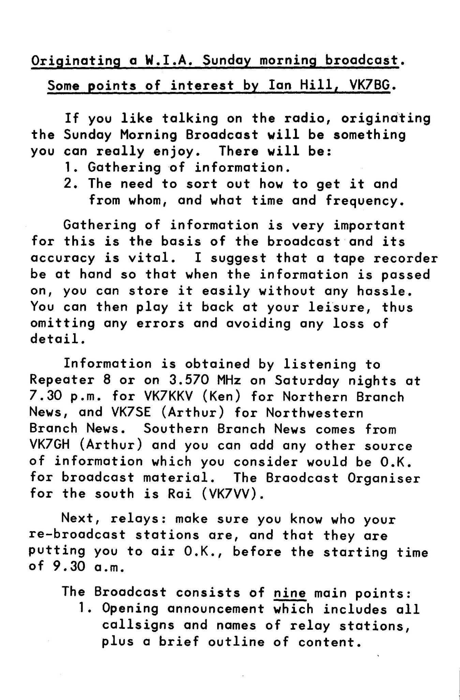
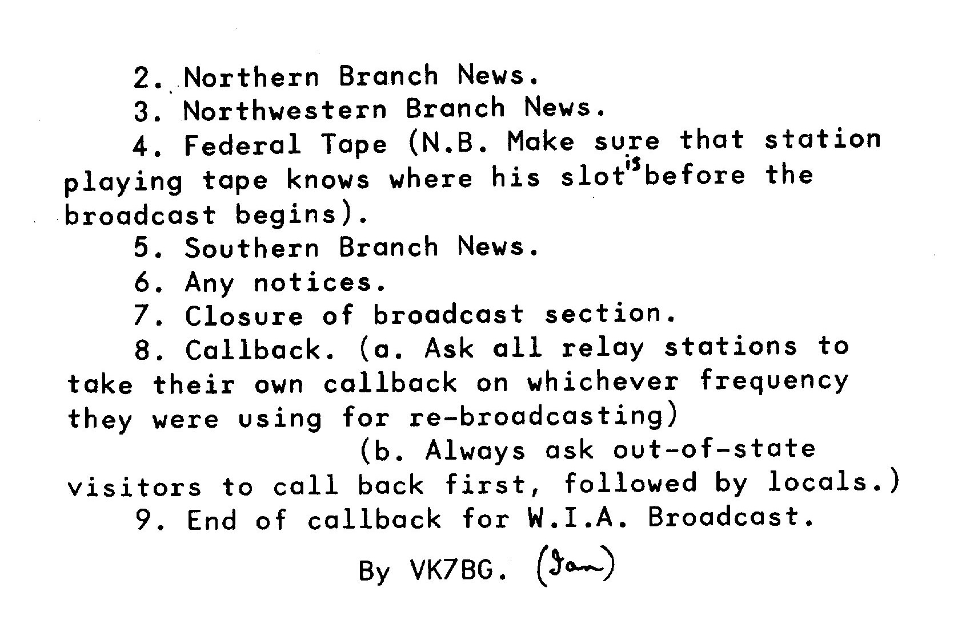
In September 1985 QRM John VK7JK raised the issue of the quality of the broadcast. With the linking of repeaters on 2m it is perfectly possible for contributors to take part from different areas of the state. With the setting up of teletype equipment it should be possible for hard copy to be transferred to the broadcast area for the use of the originator. Pre-recording a contribution was also raised as an option. John VK7DK was concerned that the whole setup revolved around a few people.
The broadcast would be recorded on Saturday night at the ABC Studios onto reel to reel tape, editing in live crosses and reports. In those days we would receive a weekly cassette tape of federal WIA news.
Mike Jenner VK7FB then became involved along with John Rogers VK7JK – 1985 through to 1990.
In QRM July 1987 john Rogers is identified as Broadcast coordinator.The new time for the WIA broadcast is noted as 0930hours on Sundays and the 40m relay is on its new frequency of 7090MHz. The relay on 80m is still on 3.570 MHz. From July 5th the broadcast will originate from Hobart. News should be sent to John VK7KDR in the northwest, Robin VK7RH in the north and John VK7JK in the south.
This was followed up in QRM in August and September with requests for volunteers to help with re-broadcasts, and more news contributions

QRM Magazine – Broadcast Rosters
1978 – 7TT, 7KH, 7KK, 7ZBY, 7AW, 7PH, 7MX, 7ZGG, 7SF, 7AL, 7RH, 7BJ, 7JG, 7HE
1979 – 7ZBY Roster 10/79 Involved – 7HK, 7KH, 7HE, 7GD, 7MX, 7RH, 7JG, 7BJ, 7TT, 7HE, 7AL, 7PH, 7ZBY, 7SF
1980 – 7GD – Sth, 7XL, 7NW, 7SF, 7TT – NW – Divisional Broadcast Officer – 7ZBY Brian Yoeman, 7TT Terry - Nth
1984 – Peter King 7ZPK – Divisional Broadcast Officer – 3/84 – From Sth – Rai Taylor 7VV
1985 – 7JK (ed of QRM)
August 1985 to March 1986 broadcast rotated around NW branch, Southern branch, Northern branch
1986 – 7GH - Sth, 7AV – Nth, 7ZFH – NW alternated 7RF, 7VV & 7AL
1987 – 7JK - Sth, 7KDR –NW, 7RH – Nth,

1990s
John Rogers VK7JK
Mike Jenner VK7FB – 199? - 2004

2000s
In 2004 the WIA moved to a National body and each VK7 Branch became a separate club.
The Radio and Electronics Association of Southern Tasmania was formed and incorporated in 2004.
The Northern Tasmania Amateur Radio Club was formed in 2004 and incorporated in 2009.
In 2008 there was a split of North West clubs into the North West Tasmania Amateur Television Group and the Cradle Coast Amateur Radio Club which was incorporated in 2009.

In 2004 the VK7 WIA Broadcast became the VK7 Regional News Broadcast and editor is still Justin Giles-Clark VK7TW. News readers are: Justin VK7TW, Ian VK7IR, John VK7JK, Barry VK7RS and Mike VK7FB.

Sourced from:
Thanks to Brian Morgan, Mike Jenner, John Rogers, Joe Gelston, Bill Maxwell, Bryan Eyre, Peter Dowd,

