A brief history of WIA and VK Amateur Radio Broadcasts in VK7
A work in progress!
Compiled by Justin Giles-Clark VK7TW and Linda Luther VK7QP from widely sourced information including many amateur’s recollections.
The structure of this article is a chronological wandering recollection from the 1920s through to present day. It is a growing catalogue of historic references to VK7 broadcasts and bulletins made in amateur radio publications, newspapers, newsletters and verbal communications.

1920s
In the publication - Radio in Australia and New Zealand Oct 15 1928 vol 2 no.6 supplement Ham notes it comments that the fifth wireless convention of the Wireless Institute of Australia was held in Hobart on August 20 1928.
Amongst the matters decided were:
“That the branches of the Wireless Institute in each State should operate a standard frequency station to transmit each week a wave which could be used by amateur for calibrating their frequency”
Whether this was accompanied by a bulletin or music is a work in progress at this point however, the callsign VK7WI appears in the callbooks from 1929 through to 1936.

1930s
In July 1931 the first bulletin appeared and contained a story stating that the Institute is holding a dance at 7ZL on Tuesday 11 August 1931 when we want to see a good roll up of members and their friends. The proceeds from the dance was to be used to buy new gear for the Institute station VK7WI.
August 1934 The Institute call 7WI should be heard again in the near future – AR Mag
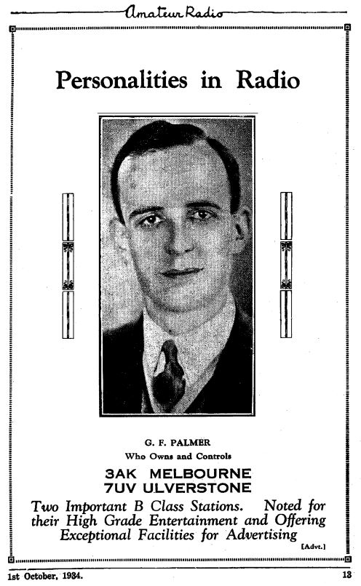
<Photo 1 - VK3AK/VK7UV 1934 Broadcast Station>
On 21 January 1935, VK7WI was given permission to broadcast music and announcements at specific times on 1310 kHz.

1940s
During the war years 1939-45 a smaller Gestenered national bulletin was produced. AR Magazine in May, June & July 1942 it listed those amateurs around Australia who were on active service during WWII.
In VK7 the list was:
Signalman G.R. Richardson VK7GR Army
Signalman R.H Kirby VK7RK Army
Corporal H Hopwood VK7GS Army
Signalman H.D.Spence VK7DS Army
Lieutenant T.Connor VK7CT Army
AC1 C.J.Robinson VK7KR RAAF
AC1 K Saxon VK7ER RAAF
There was also a humourous column each month called Slouch Hats and Forage Caps.
September 1945 was the first post war edition of AR Magazine and on 31 August 1945 the Tasmanian Division was reactivated on 31/08/1945 with 12 members. One of the Federal Councillors is list as M.L.Loveless VK7ML of Winnie the War Winner Fame. By August 1947 there were more than 50 members.
March 1947 the WIA Tasmanian Division meeting resolved that an interstate regchew be held on the 2nd and 4th Fridays each month on 3.5 & 7 Mc as condition warrants zero hour was 8pm – A phone broadcast of the Division’s general activities is to be part of each evening’s programme and VK7CT to have charge of this item. An official transmission from VK7WI be introduced when it becomes practicable.
In August 1947 it was reported that there was a bimonthly VK7WI broadcast and interstate ragchew on 7 Mc.
In November 1947 there was comment about the dangers of QRMing the broadcast harmonics on 3.5 Mc of a Sunday morning.
In June 1948 VK7WI was on air at 9:30am on the second and fourth Sunday of each month and the frequency was 7.174 Mc.

1950s
There were a number of notable amateurs involved in putting the WIA broadcast to air in the 1950s. This included Bob Fulton VK7AF, Terry Connor VK7CT, Jack Batchler VK7JB, Tom Allan VK7AL and many others.
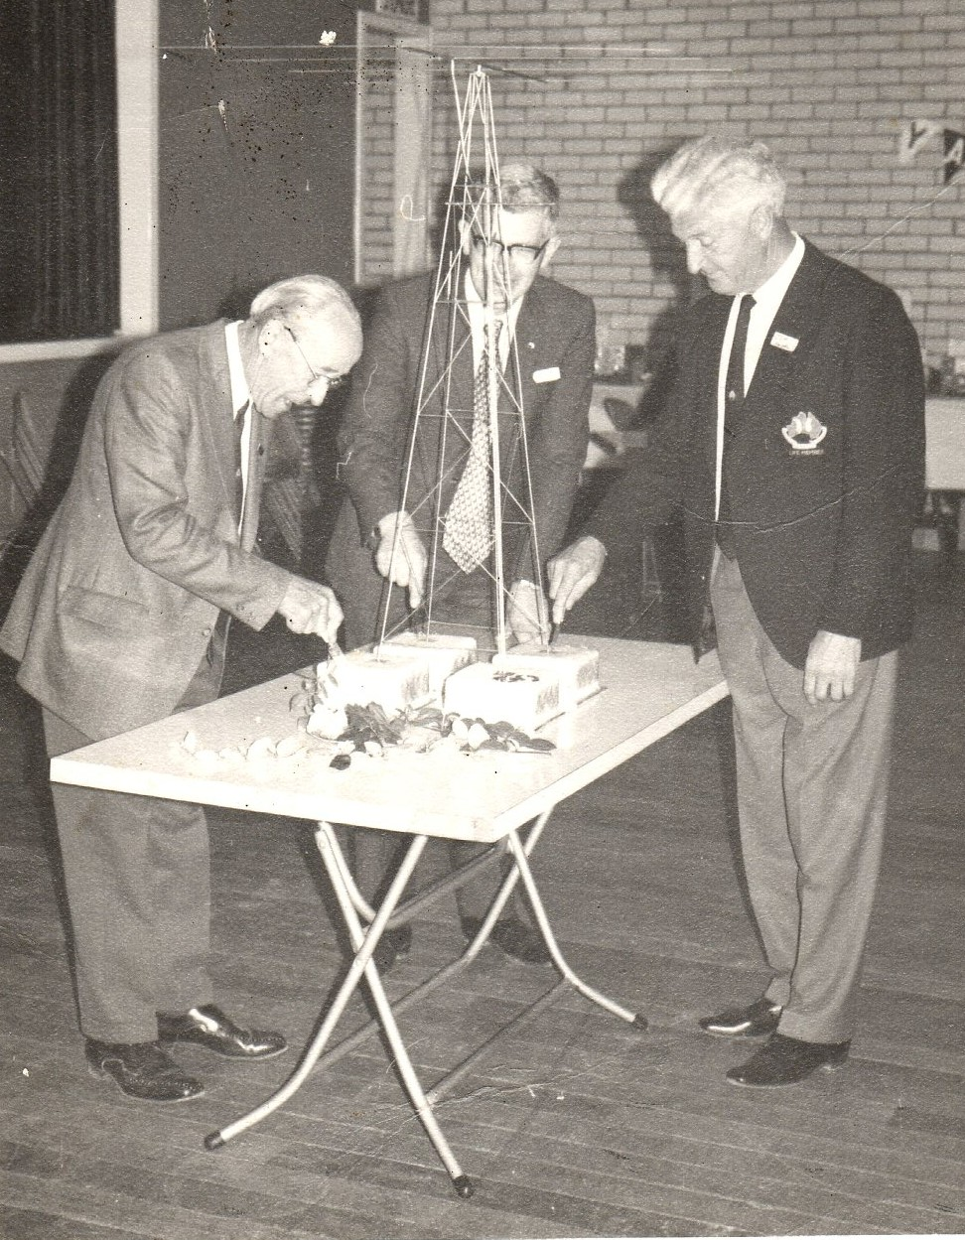
<Photo 2 - L2R - Max Ives VK7MX (SK), Peter Frith VK7PF (SK) and Tom Allan VK7AL (SK)>
Terry VK7CT was a pipe smoker and had the habit of tapping out his pipe as he spoke, so you always listened, expecting to hear this.
Tom VK7AL took over coordination of broadcasts and continued on and off for many years. The broadcast in those days often consisted of reading the contents of the locally produced VK7 Bulletin (not THE Bulleting), but the VK7 monthly news letter, which Tom used to pronounce as the “Bullet INN”.
We know Tom did the broadcast in 1959 from the WIA meeting rooms in Liverpool St, Hobart. Tom like many amateurs at the time worked for the PMG.

1960s
Through the 1960s Tom VK7AL originated the WIA broadcast on 40m and recollections are that it was quite noisy in Launceston.
Bill Maxwell VK7MX recollects in the early 60’s – trudging across the back suburbs of Burnie to Sid Medfords VK7SF’s to listen to the 40m AM broadcast and one day heard that the storm overnight had sunk some caissons that were being used to build the breakwater in Burnie – Ken Hancock VK7KH could see from his shack window – it was the highlight of the week!
John Grace VK7ZJG rebroadcast WIA news on Sunday mornings for many years on 144.1 MHz AM and then SSB, later on 144.15 MHz in the early 1960s.
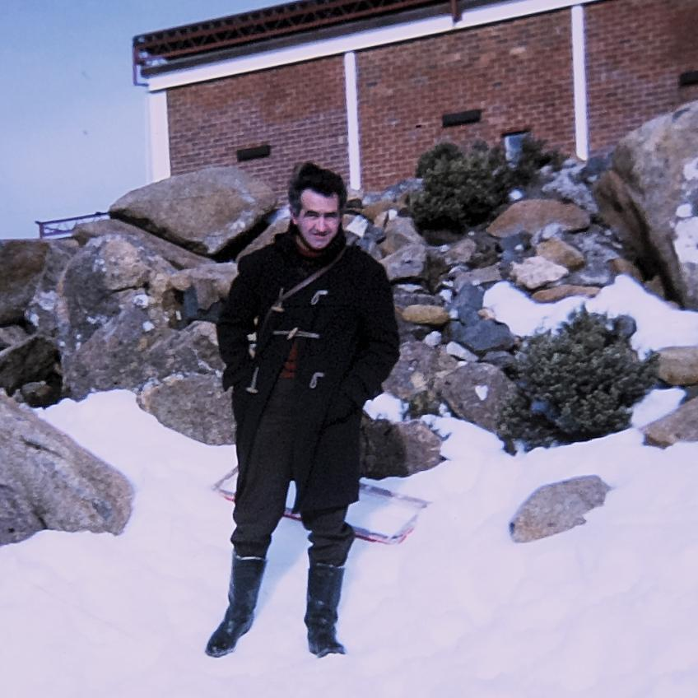
<Photo 3 - John Grace VK7ZJG (SK) - TVT6 Mt Wellington 1968/69>
In May 1964 a note in the Bulletin newsletter states that VK7WI rebroadcasts and slow morse, have temporarily ceased, due to the absence of Den Kelly VK7DK.
In 1967, Brian Morgan VK7RR was the editor of the Bulletin magazine and with it, came the responsibility of also collating and reading the broadcast news.
Peter VK7PD remembers hearing it on 2m AM which was picked up by Den VK7DK from 40m AM where it originated. Launceston at that stage had cross band repeaters on 2m & 6m.

1970s
The 70’s saw the formation of the Southern, Northern and North West Branches of the WIA Tasmanian Division and broadcasts alternated between Hobart, Launceston and Burnie each week. There early 1970 saw the demise of the Hobart derived Bulletin newsletter and a regular VK7 Newsletter called QRM produced from Launceston that was a great source of material about VK7 broadcasts.
Peter Dowde VK7PD recollects that during the time the broadcast originated in Launceston – Peter Frith VK7PF increased the frequency of the repeater ident tone outside the bandpass of an SSB receiver so it didn’t get passed through to the SSB rebroadcasting.
In Launceston, Brian Yoeman VK7ZBY and Reg Emmett VK7KK were involved and Tom Allen VK7AL, Ted Beard VK7EB, Brian Rieusset VK7VK, Snowy Harrisson VK7CH and Tommy Moore VK7FM were involved in Hobart. There was use of ABC facilities to create and edit the broadcast.
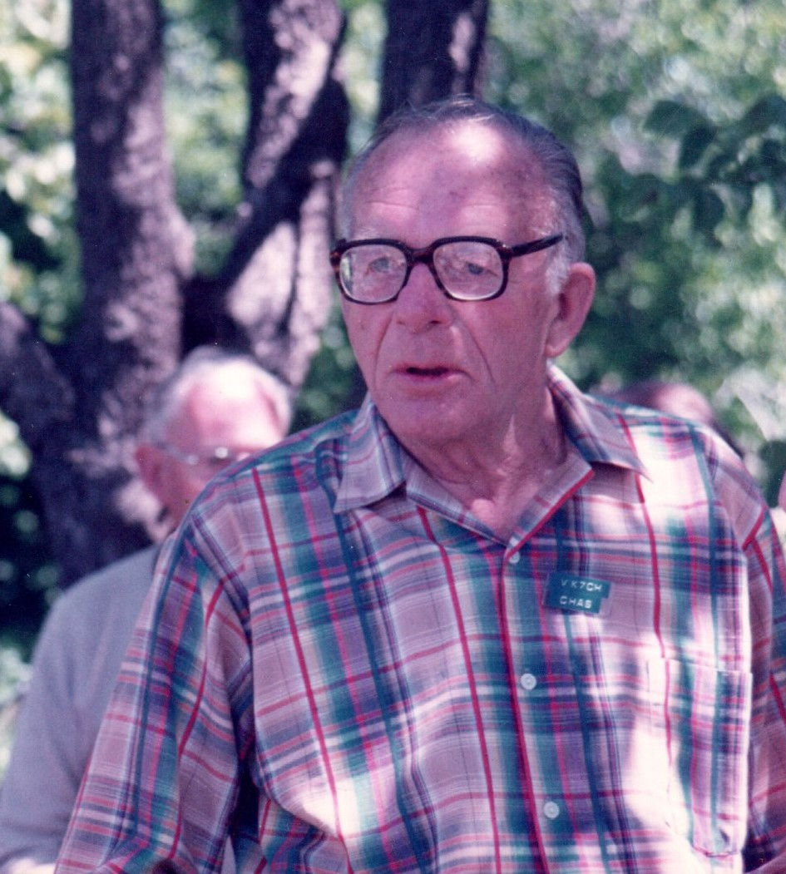
<Photo 4 - Chas (Snowy) Harrisson VK7CH (SK)>
Tom VK7AL had worked as a technical trainer with the ABC for years, and Brian VK7VK was also technically trained, working with the ABC and later with the Tasmanian College of Advanced Education and various colleges in Hobart.
1971 – There are QRM comments in the May edition - ‘with the likely withdrawal of the Tasmanian Division Bulletin a number of the Northern Zone members have felt the need for some form of communication’. Comment is made that Den VK7DK presented the best amateur travelogue heard!
QRM 1972 – Northern zone meeting in July stated that a request is expected for the zone to be responsible for originating the Sunday WIA broadcast. It is hoped that members will assist in offering ideas and information to ensure a top-rate production. Transmission on the repeater as well as HF is envisaged. By November the weekly news broadcast was coming from the Northern Zone and the job of newsreader is in the capable hands of Reg Emmett VK7ZAO and was broadcast on – a local 2 meter frequency, an AM 7 MHz broadcast suited to transistor radios, dual wave radios etc and an immediate publicity channel for local notes.
Joe Gelston VK7ZGJ was involved with in 1972 for 12 months and recollected that repeater 2 (Mt Wellington - Hobart) and repeater 8 (Mt Barrow – Launceston) were linked by two radios back to back at Arthurs Lake in the Central Highlands (Frank Moore’s place) he used a chainsaw in the tree to make a hole with extension cord and generator and this arrangement was in place for two years. The VK7RIN repeater - link on Barren Tier in the Central Highlands took over and is still going strong.
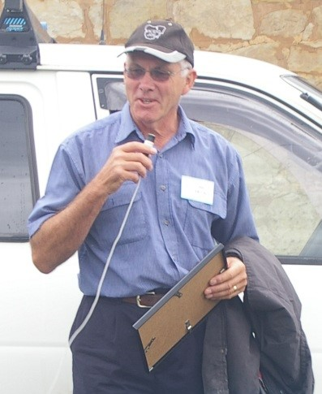
<Photo 5 - Joe Gelston VK7ZGJ/VK7JG (SK)>
QRM 1973 – No broadcast officer listed in office bearers later in the year Reg VK7KK was list as Broadcast Officer. There were constant calls for information and broadcast material.
QRM 1974 – No broadcast officer listed in Branch Officers and the DX notes for the broadcast was supplied by Den VK7DK.
QRM 1975 – NW Broadcast coordinator Tony Bedelph VK7AX – The NW branch has had a very successful year regarding broadcasts was the report. At the Divisional AGM several members praised the efforts of the Broadcast Officers for the consistency and quality of the broadcasts. 1975 saw the first 432 MHz ATV broadcasts. Originating frequencies now include VHF which allowed Z calls to act as originating stations.
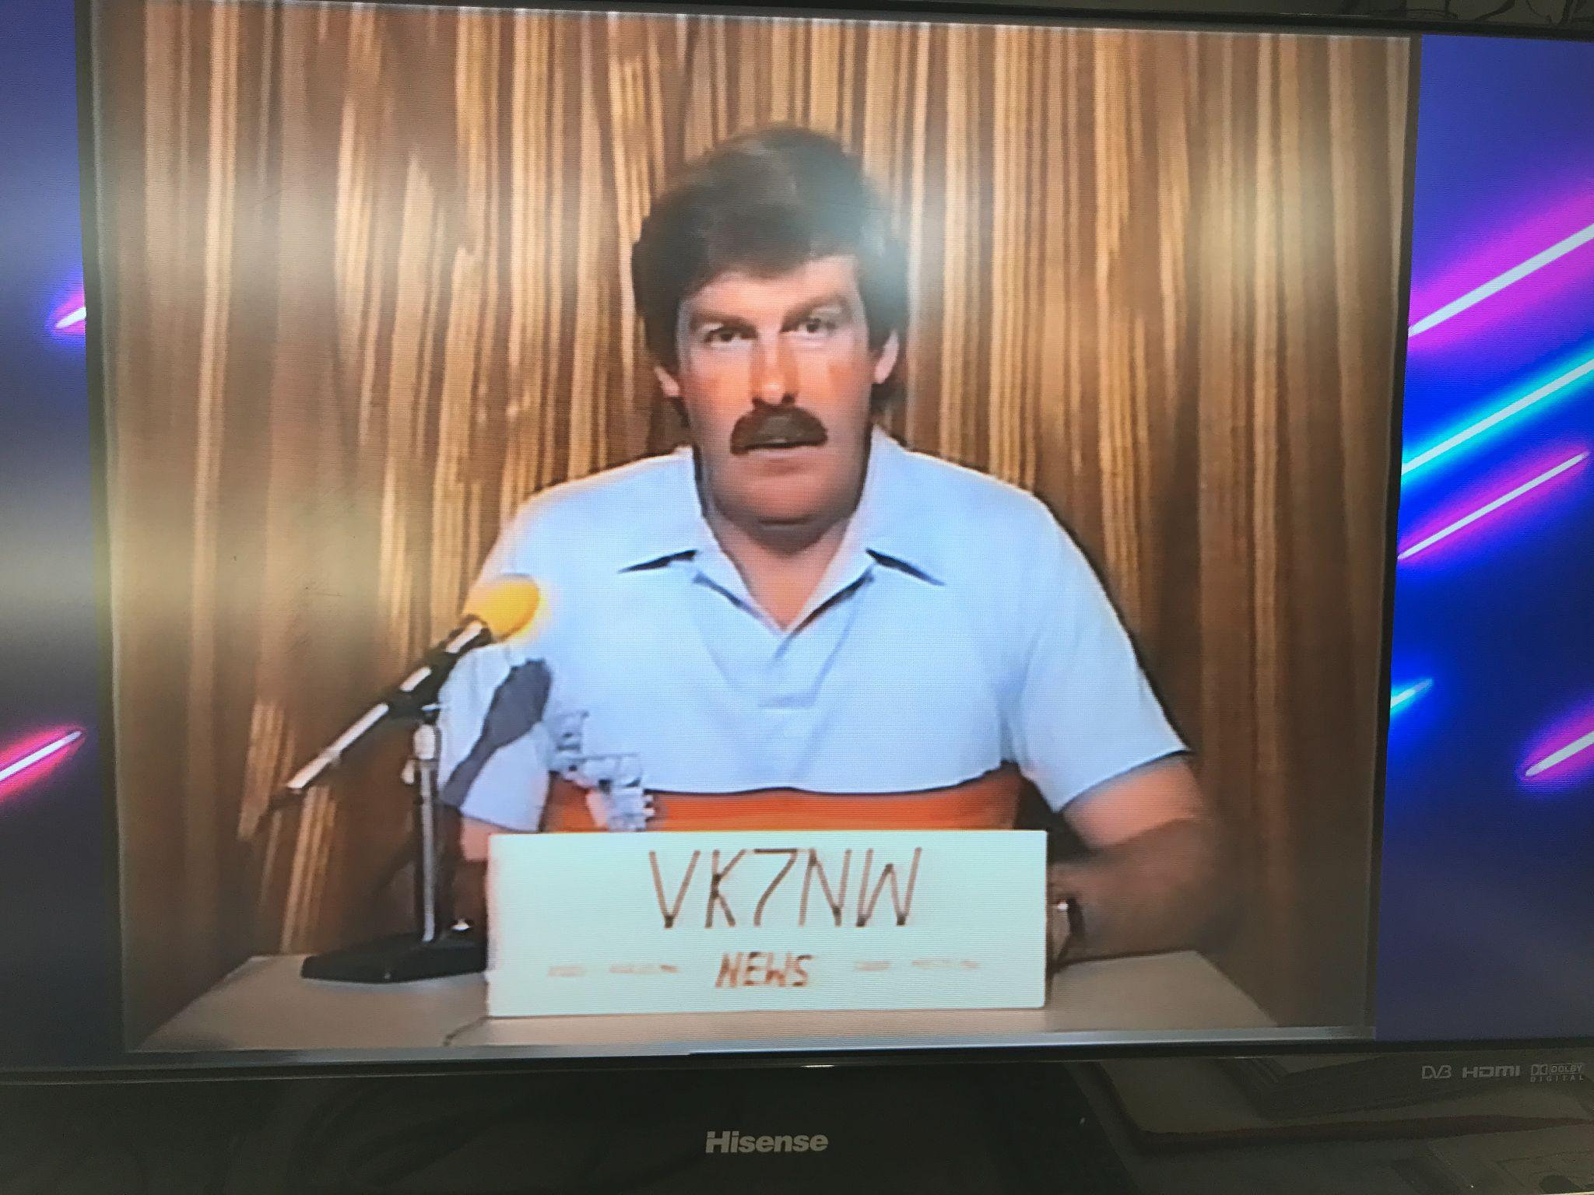
<Photo 6 - Tony Bedelph VK7AX ATV Broadcast News>
At the general meeting following the VK7 AGM on 5 April 1975, Brian VK7ZBY enquired of those present if they were happy with the systems in place for the broadcast. There was reassurance that all was satisfactory. Those involved with the Sunday morning broadcasts whether originating or re-broadcasting were thanked for their efforts in the past and in the future
In May 1975 it was announced that the WIA broadcast may soon be originated on the 432 MHz in ATV, an important first for the Tasmanian zone. Graeme Reardon VK7ZGG in Launceston, newsletter editor, raised the issue of what band the broadcast should be originated as 80 metres has always been the primary frequency for statewide broadcasting as it is the only frequency used which can reliably transmit across the whole state. On the other hand, originating the broadcast on VHF frequencies does allow Z calls to act as originating stations and thus giving others a chance at collecting and giving the news.
The 5th October 1975 saw the very first ever Divisional News ATV broadcast in VK right here in Southern VK7 on UHF frequencies. Tom Moffat VK7TM, and Andrew Boon VK7AW organised the transmitter and convertors that were offered to amateur through the WIA VK7 Disposals group. Brian Morgan VK7RR volunteered as the news reader. This story is covered in AR Magazine December 1975.
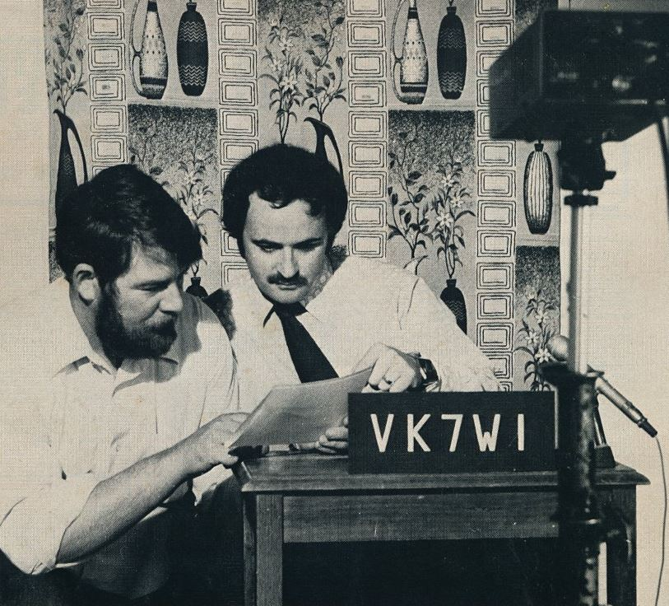
<Photo 7 - Front cover photo AR Magazine December 1975 - Tom VK7TM (SK) and Brian VK7RR>
In 1976 Col Wright VK7LZ in Launceston was broadcast and relay officer.
QRM 1976 - An evening broadcast was discussed and it was decided to have a tape replay on the Sunday morning broadcast on repeater 8 (147.000 MHz) on a Wednesday evening. Discussion of a change of frequency for the 80m broadcast from 3.672 to 3.570 MHz to bring it into the newly formed Novice band. A volunteer was called for to rebroadcast the VK7WI news on 27.125 MHz? Broadcast officer was Ian Ellings VK7ZIE (Now VK7QF).
QRM 1977 – No broadcast officer nominated.
In the 1970s Repeater 2 moved from Mt Wellington to Guy Fawkes Hill and the UHF link maintained between the repeaters in the North and South.
Mike Jenner VK7FB who by then was living at the Hobart 7ZL transmitting ABC Broadcast site with a HF station and was involved with the broadcast.
QRM Magazine – Broadcast Rosters
1978 – 7TT, 7KH, 7KK, 7ZBY (Broadcast Officer), 7AW, 7PH, 7MX, 7ZGG, 7SF, 7AL, 7RH, 7BJ, 7JG, 7HE
1979 – 7ZBY Roster 10/79 Involved – 7HK, 7KH, 7HE, 7GD, 7MX, 7RH, 7JG, 7BJ, 7TT, 7HE, 7AL, 7PH, 7ZBY, 7SF
1980s
Barry Riseley VK7RS was involved with getting the broadcasts to air in the early 1980's maybe earlier when Lloyd Cherry VK7BF was involved.
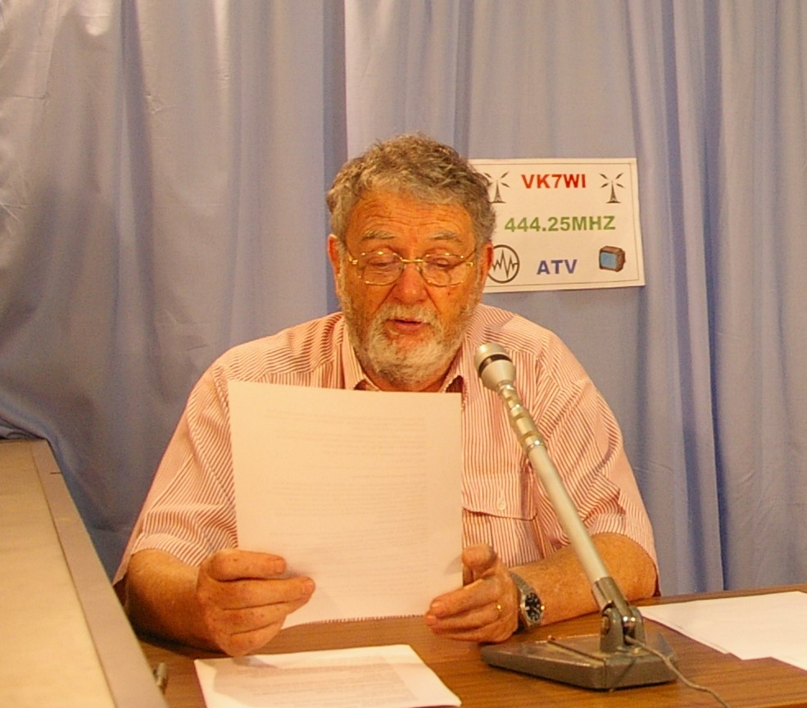
<Photo 8 - Barry Riseley VK7RS (SK)>
Barry VK7RS used to listen to the broadcasts on 40m in the early 1950's, firstly courtesy of Peter Allen in Moonah (Tom Allen's elder brother) and then on a shortwave converter Barry built circa 1957/58.
Barry Fraser VK7FR who was ABC TV news reader became involved in the early 1980’s through until 1985 when Barry retired and moved to the NW Coast.
We know from the QRM Newsletter of April 1984 that Ian Hill VK7BG put together some notes for originators of the weekly broadcast.
“Information is obtained by listening to Repeater 8 (147.000 Mt Barrow) or 3.570 MHz on a Saturday night at 7:30pm. In the South the organiser was Arthur VK7GH, in the North – Ken VK7KKV and in the North West – Rai VK7VV for their respective branch news”
The Federal broadcast was delivered via a cassette tape and slotted into the sequence.
In September 1985 QRM - John Rogers VK7JK raised the issue of the quality of the broadcast. With the linking of R8 (147.000) and R2 (146.700) repeaters on 2m it is perfectly possible for contributors to take part from different areas of the state. With the setting up of teletype equipment it should be possible for hard copy to be transferred to the broadcast area for the use of the originator. Pre-recording a contribution was also raised as an option. Den Kelly VK7DK was concerned that the whole setup revolved around a few people (sound familiar!!!).
The broadcast would be recorded on Saturday night at the ABC Studios onto reel to reel tape, editing in live crosses and reports and including the federal WIA news from the provided cassette.
Mike VK7FB also became involved along with John VK7JK from 1985 through to 1990.
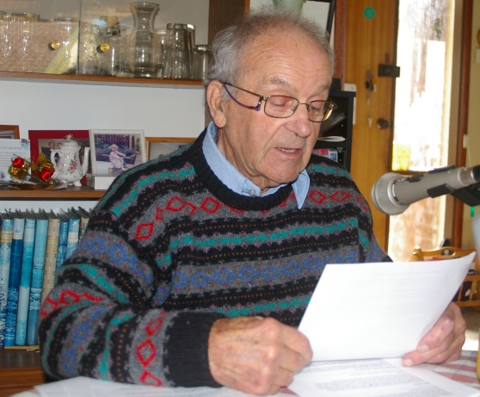
<Photo 9 - John Rogers VK7JK (SK) reading his last broadcast in 2008>
In QRM July 1987 John VK7JK is identified as Broadcast co-ordinator. The new time for the WIA broadcast is noted as 0930 hours on Sundays and the 40m relay is on its new frequency of 7.09 MHz. The relay on 80m is still on 3.57 MHz. From July 5th the broadcast will originate from Hobart. News should be sent to John Webster VK7KDR in the North West, Robin Harwood VK7RH in the North and John VK7JK in the South.
This was followed up in QRM in August and September 1987 with requests for volunteers to help with re-broadcasts, and more news contributions
QRM Magazine – Broadcast Rosters
1980 – 7GD – Sth, 7XL, 7NW, 7SF, 7ZBY, 7TT – NW – Divisional Broadcast Officer
1984 – Peter King 7ZPK – Divisional Broadcast Officer – 3/84 – From Sth – Rai Taylor 7VV
From 1985 John VK7JK was editor of QRM where most of the material was sought for the broadcast.
From August 1985 to March 1986 the broadcast rotated around NW, Southern and Northern branches
1986 – 7GH - Sth, 7AV – Nth, 7ZFH – NW alternated 7RF, 7VV & 7AL
1987 – 7JK - Sth, 7KDR –NW, 7RH – Nth,
From 1988 John Rogers VK7JK took over the broadcast production. John was a former school teacher and school inspector and flew photo reconnaissance Mosquitos out of Singapore during WWII.

1990s
John VK7JK continued throughout the 1990s as the broadcast officer with assistance from Mike Jenner VK7FB who is still involved with broadcast reading today.

2000s
In 2002 the Author took over as broadcast coordinator and AR Magazine VK7 Column editor from Ron Churcher VK7RN and in 2004 the WIA moved to a National body and each VK7 Branch of the WIA Tasmanian Division became a separate club.
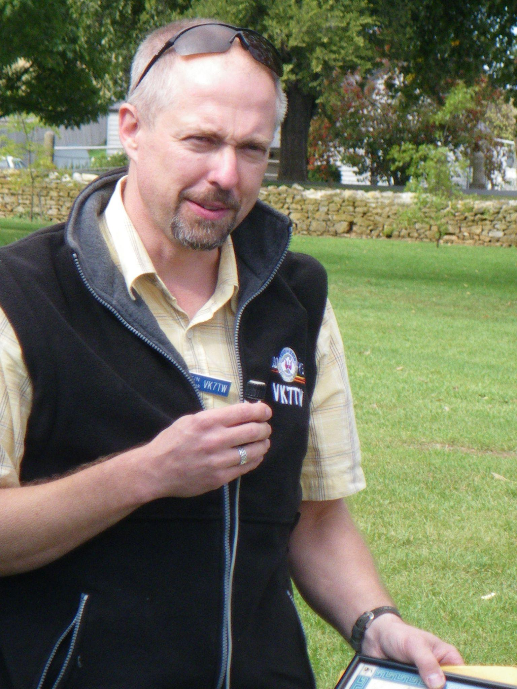
<Photo 10 - Justin Giles-Clark VK7TW>
In the South the Radio and Electronics Association of Southern Tasmania, based in Hobart was incorporated in 2004.
In the North the Northern Tasmanian Amateur Radio Club based in Launceston was formed in 2004 and incorporated in 2009.
In the North West – the North West Tasmania Amateur Radio Interest Group was formed which later became the Cradle Coast Amateur Radio Club and was incorporated in 2009. The North West Tasmania Amateur Television Group was also formed and later became the North West Tasmania Radio & TV Group and then later became the North West Tasmania Amateur Radio Club. In the North West the broadcast is transmitted using repeaters and Amateur Television.
In 2004 the VK7 WIA Broadcast became the VK7 Regional News Broadcast and later the VK7 Amateur Radio News and editor is still yours truly. News readers started in 2004 with Justin VK7TW, Ian VK7IR (SK), John VK7JK (SK), Barry VK7RS (SK) and Mike VK7FB.

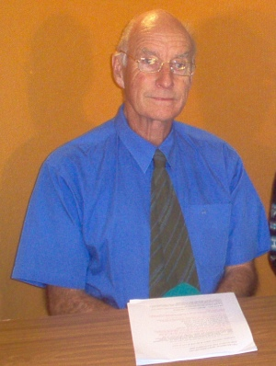
<Photo 11 - Ian Milne VK7IR (SK)>
In 2023 the newsreaders include - Justin VK7TW, Mike VK7FB, Rick VK7RI, Idris VK7ZIR, Peter VK7PD.
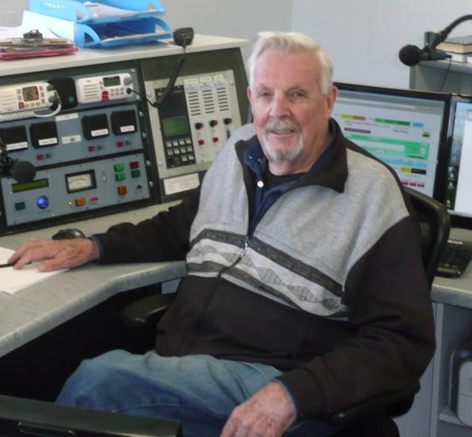
<Photo 12 - Mike Jenner VK7FB>
There are many people involved in the rebroadcasting each Sunday morning and Tuesday night these include – VK7GS, VK7TPE, VK7JGD, VK7DG, VK7ALH, VK7FMAC, VK7ZCR, VK7AX, VK7YBG, VK7DW, VK7KPC. Callback operators include – VK7DW, VK7LEE, VK7HXT, VK7TW, VK7FB, VK7KPC, VK7PD, VK7AX, VK7JH.
In 2023 Repeater Two – 146.700 was moved from the REAST clubrooms back up to Mt Wellington as VK7RHT and reconnected to VK7RAA on Mt Arthur in Northern Tasmania and the VK7 Amateur Radio Broadcasts returned to being a truly statewide broadcast originated from Hobart. History repeating itself!
Sourced from:
Thanks to Brian Morgan VK7RR, Mike Jenner VK7FB, John Rogers VK7JK SK, Joe Gelston VK7JG SK, Bill Maxwell VK7MX, Bryan Eyre VK7KBE SK, Peter Dowd VK7PD, Linda Luther VK7QP, Richard Grace VK7ZRJ, AR Magazine Archive, QRM Magazines and various other sources and personal communications.

